2020 год

Версия 8
Руководство пользователя АПК «НейроЧат»

Table of Contents
Quick Guide 4
Introduction 7
Use Purposes and Requirements 8
Connection Options 10
2. Installation and configuration of the program 12
2.1. Installing NeuroChat 12
2.2. Registration 13
2.3. Autorisation 15
2.4. Adding a contact 16
2.5. Connect phone number 18
2.6. Network Setup 19
2.7. Program launch, first time settings 24
3. About Neuro-headset «GARANT-EEG» 26
3.1. Installing Battery 27
3.2. Turning on the Amplifier 28
4. Preparing to work with the headset 29
4.1. Program Launch 29
4.2. Installing the headset of the head of a user 32
4.3. Calibration Guide 35
4.4. Keyboard settings, types of flashes 39
5. System Operation 43
5.1. Client Startup Window 43
5.2. Main Menu 45
5.3. Contact Selection Window 48
5.4. Chat Window 49
5.5. Message Window 51
5.6. Notepad 52
5.7. Sleep Mode 54
5.8. Finish working with the Neuro-headset 55
5.9. Cleaning and Disinfecting the Neuro-headset 56
5.9.1. Step-by-Step Cleaning Guide 57
5.9.2. Disinfecting the Neuro-headset 58
6. Emergency Situations 60
6.1. No Signal (EEG not responding) 60
6.2. No Server Connection 62
6.3. Message «Waiting for Calibration Results…» 63
6.4. Message «Connection issue with the following electrodes…» 65
6.5. Physically Damaged Electrodes 67
6.6. Forced Shutdown of Electrodes 68
7. «Memory» 71
8. Training Mode 76
9. Screen Designer 80
9.1. Editing the Screen 80
9.2. Button Setting 82
9.2.1. Changing Images Inside the Buttons 85
9.2.2. Setting Buttons to Switch to Other Windows 87
9.2.3. Image Format Requirements 88
9.3. Screen Creation and Loading 90

Quick Guide
Step 1.
Register on the website https://srv.neurochat.ru/, download the NeuroChat software package and install the program on your computer.
At the start, enter your login / password details in corresponding windows (section 2.7.), and set up the Wi-Fi to work with the headset (section 2.6).
Step 2:
Remove the cover from the amplifier and insert a fully charged battery, then put the cover back on. For the amplifier to work properly place it horizontally, base down. Use light force to double tap the top of the amplifier. After a few seconds a green light will start blinking meaning the amplifier is on. Connect the amplifier to the computer through Wi-Fi (section 2.6). Choose a device the name of which starts with «EEG8_». Provide NeuroChat password during the first connection with the neuroheadset
Step 3:
Launch NeuroChat and connect the Neuroheadset to the program (section 4.1.). After connecting the headset to the program NeuroChat make sure that all indicators on the front side of the amplifier are on.
IMPORTANT:
Note that the amplifier should first be connected to the computer, and only then to the program.
Step 4:
Place the pad with electrodes on the headset, attach the amplifier to the strap and connect it to the previously installed pad. Then put the headset on the head of the user and adjust the size by twisting the adjustment knob, as well as the pegs on the headset and the corresponding slots in the rubber pad. Insert the connector into the amplifier. (section 4.2). Attach the ear electrode to the user’s earlobe.
Step 5:
Open EEG-info tab. Apply the conductive gel on the ear electrode (REF) first followed by the frontal lobe (GND), after which start applying the gel on the rest of the electrodes. To do so, use the syringe filled with gel to fill in the designated holes in the rubber pad (section 4.2.), or lightly lift each electrode on the rubber pad and apply gel on the surface of the user's head. On an EEG-info screen you are able to see current connection quality between the electrodes and user’s skin. You can use the screen as a reference to determine which electrodes need more gel for better conductance. (section 4.1.).
Step 6:
Start calibration (section 4.3.). If necessary, adjust the speed of flashes. (section 4.4.). By the end of the calibration choose the appropriate menu (start again, chat, or go back). The working principle of chat is described in section 5, games in section 7, screen designs in section 9.
Step 7:
After using the headset the gel should be removed and cleaned immediately. (section 5.9). To do so, take off the headset from the user’s head by loosening up the adjustment knob, then remove the rubber pad with electrodes and disconnect it from the amplifier by unplugging the cable.
IMPORTANT: When washing the headset remember to keep the cable away from water, as well as the amplifier.

The rubber pad should be washed with warm water. First, wash off the gel using your hands, then use the cleaning brush provided to carefully remove the excess gel from the inner parts of the electrodes. Let the headset dry naturally, don’t use heat.

Introduction
Hardware-Software complex NeuroChat is a communication tool for interaction with relatives, medical personnel and others with no speech or movement. With help of NeuroChat user is able to type words by letters, use symbols, as well as notify about his needs. Regardless of the severity of the case and user’s abilities when using NeuroChat there is a provided training mode and various adjustable settings.
Before using NeuroChat it is important to be familiarized with the given user manual.
Neurochat’s visual interface includes a set of screens used for choosing different types of commands (select activity, select contact from the list, move to typing and sending messages, move to viewing conversation history), navigation between which is carried out through special navigation buttons which users can choose independently.
Besides being able to input texts, NeuroChat users can express their needs through special corresponding commands. Options can be expanded by creating customised screens with graphical interface - pictograms, as they reflect simple commands. This could be useful for users who may find typing difficult or even impossible.
USE PURPOSES AND REQUIREMENTS
WARNING
Before using HSC «NeuroChat» it is recommended to consult with a specialist (attending physician), as the program NeuroChat creates additional cognitive load on the brain.
NeuroChat is not recommended for people with high convulsive activity, as well as people prone to rapid mental fatigue, sudden jumps in blood pressure and headaches.
It is important for users to monitor their health throughout the process and stop immediately if condition worsens.
The intensity of using HSC «NeuroChat» has to be planned in accordance with the user's needs and capabilities.
To work in NeuroChat the following conditions has to be met:
- User’s cognitive abilities must be preserved at a level that is sufficient enough to understand the rules of operating the system.
- User must be able to complete required instructions when working with HSC: concentrating his gaze and focus his attention on a particular object shown on the screen.
- User’s eyesight (including corrected) must be sufficient to see and determine graphical or literal symbols on the screen.
- User must understand speech.
- User must be registered on the website srv.neurochat.ru.
Hardware-software complex must be installed on personal computer with characteristics given bellow:
- Operating system: family Windows (Windows 7 SP2 and higher), Ubuntu 17.10 and higher;
- Refresh rate of the screen should be at least 60Hz;
- Minimum required processor - Intel Core i5 with a frequency of at least 2.5 GHz;
- RAM at least 4 Gb;
- 2GB (2048MB) of free hard drive space
- Network interface with a data transfer speed of at least 10 Mbps; Н
- Wi-Fi module to connect the headset.
IMPORTANT:
If you do not know the characteristics of your PC or have difficulties finding it out, call technical support for help.

Connection Options
HSC «NeuroChat» requires access to the Internet with a speed of at least 10 Mbp/s and Wi-Fi module. There are two possible connection options.
- First option is to use Ethernet cable to connect the PC to the Internet and then connect the amplifier to the computer using the built-in Wi-Fi module. In case the stationary PC is used, it is necessary to use Wi-Fi module and make sure the Wi-Fi module is built into the computer motherboard. 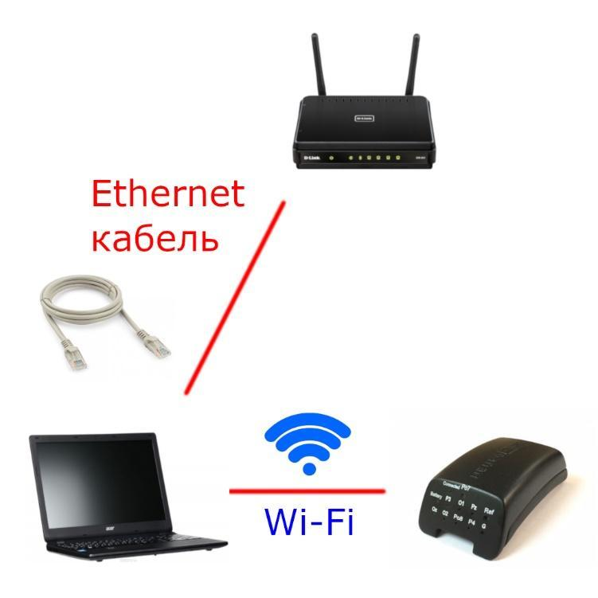
Illustration 1. Connection option № 1

- Second option requires two available Wi-Fi modules. One is used for connecting the PC to the Internet, whereas the other module is used to connect the amplifier to the computer. If the laptop is used instead, then one Wi-Fi module is already built-in, and the other module has to be connected through a USB port. For a stationary PC it is often necessary to either connect two external Wi-Fi modules or connect using option/scheme 2. To connect to the Wi-Fi module you may have to download additional software.
IMPORTANT: This connection option requires connecting two Wi-Fi modules. Connecting with one external Wi-Fi module or using only built-in module is impossible.
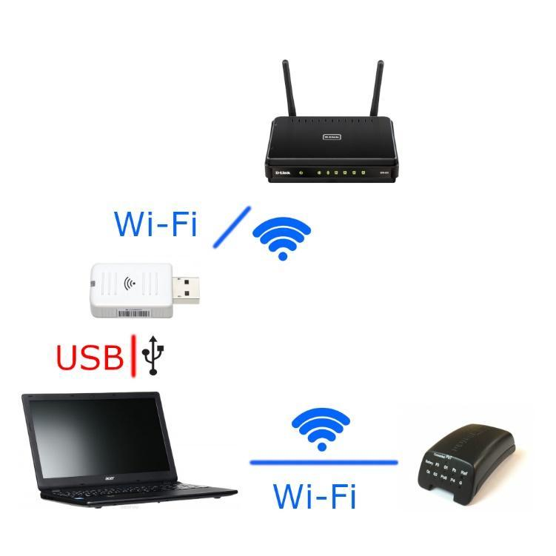
Illustration 2. Connection Option № 2

2. Installation and configuration of the program
2.1. Installing NeuroChat
Download the installer via link srv.neurochat.ru (drag the cursor on the link, hold the «Ctrl» button on the keyboard and left-click).
If the downloading did not begin automatically, go to srv.neurochat.ru website, press «download» on the top menu and select the type of a client depending on the operating system you are using.
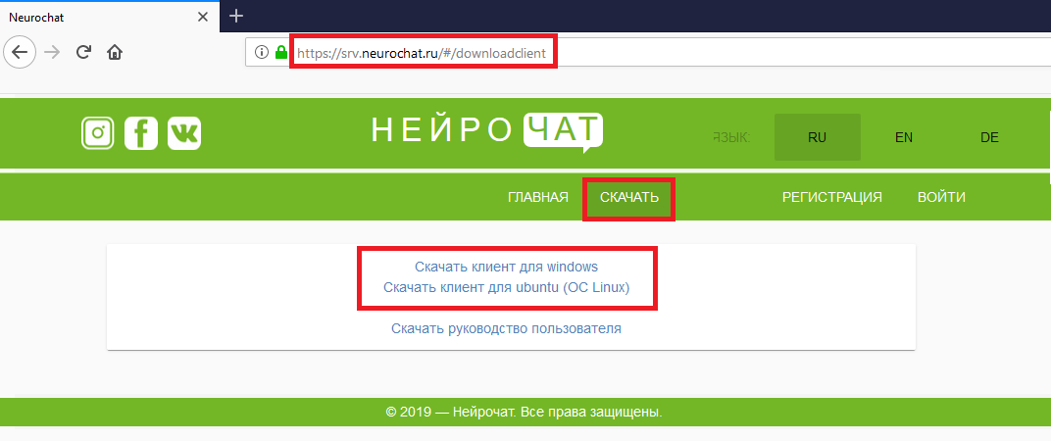
Illustration 3. Page with NeuroChat distributions.
Download the desired distribution package and run the installer of «Neurochat.exe», following the instructions on the screen. For Linux users, there is an additional installation instruction provided in archives.
Wait for the installation to complete, then select «register online» and click the «complete» button (Illustration 4).
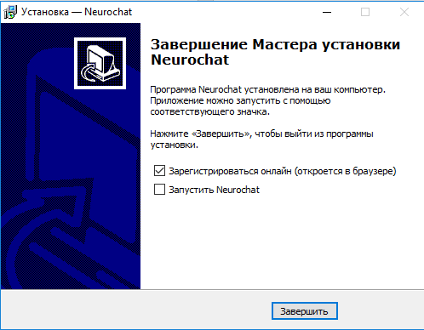
Illustration 4. Installing NeuroChat
2.2. Registration
IMPORTANT: For entry and authorization on the http://srv.neurochat.ru website it is recommended to use Google Chrome browser.
To create a new user in «NeuroChat» system type следует http://srv.neurochat.ru in the address bar of the browser (Illustration 5). When the installation of «NeuroChat» software is completed, the website will automatically open in the browser.
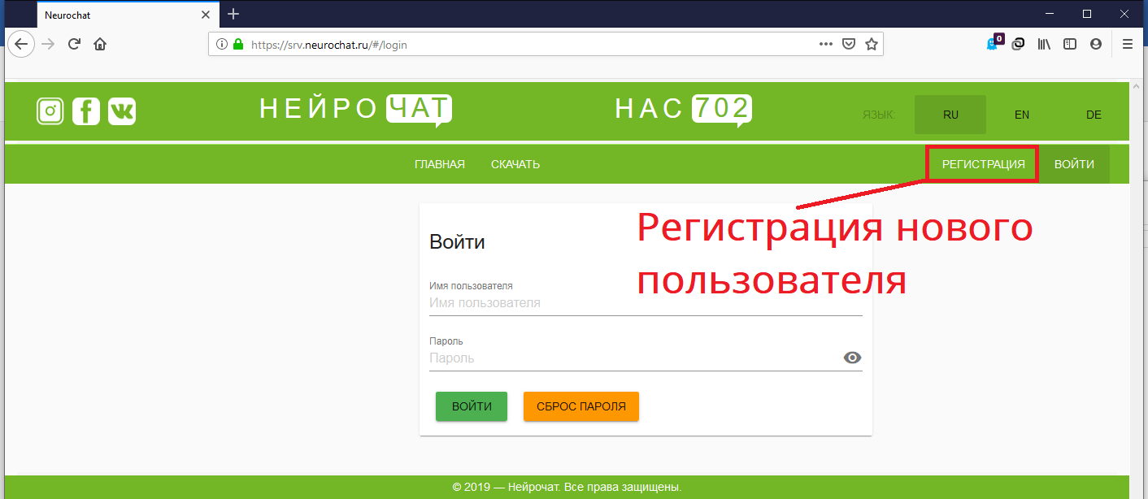
Illustration 5. http://srv.neurochat.ru website. Authorization/registration.
Fill in all the necessary fields in the new user registration form (Illustration 6) then click «Register».
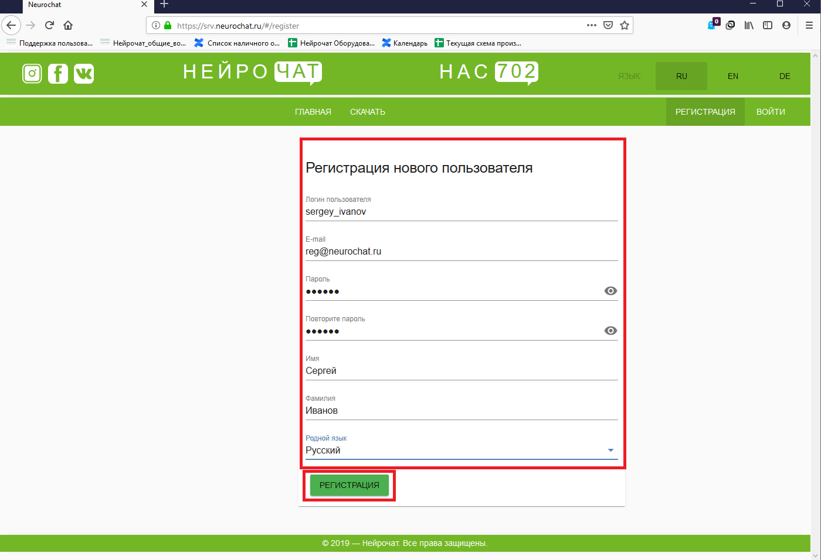
Illustration 6. New user registration window.

IMPORTANT: It is recommended to fill in the «User Login» field starting with «name», then «surname» format, using English lowercase letters (for example, sergey_ivanov). Fields «Name» and «Surname», should be filled in Russian, Capital letters (Name – Сергей, Surname – Иванов).

2.3. Authorization
To work with «NeuroChat» system user has to register at http://srv.neurochat.ru. In «Login» field enter the «user_login» that you selected during registration, in «Password» – selected password during registration, then click «Login» button.

2.4. Adding a contact
When authorized in system «NeuroChat» go to the «Profile» section (Illustration 7).
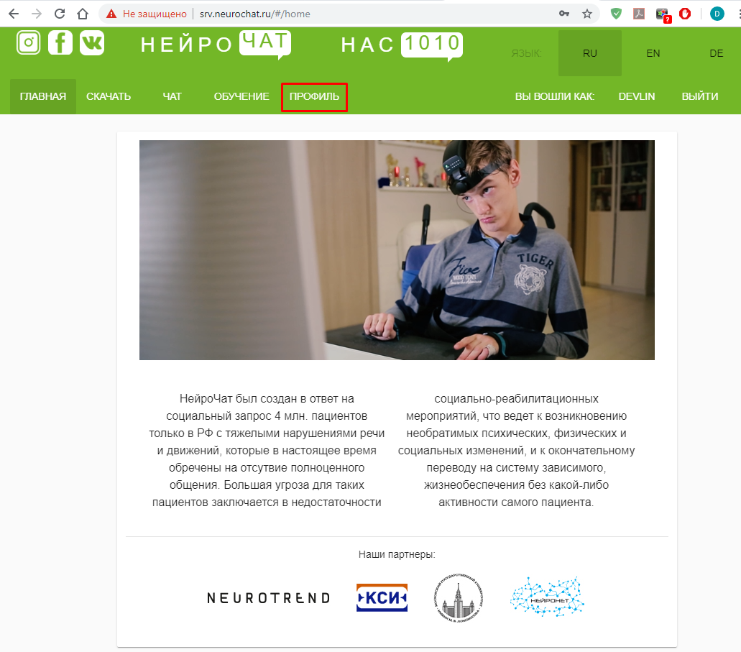
Illustration 7. «Profile» section.
To add a new contact in your friends list go to the «Contacts» section [1]. Select the network you wish to use (NeuroChat or Viber) [2], then select «search contacts» [3], enter the username in the search bar and click «search» [4] (Illustration 8).
At the bottom of the screen you will see a selection of users with selected names. When the correct contact is found, click «+» in the red circle on the right hand side of the name.
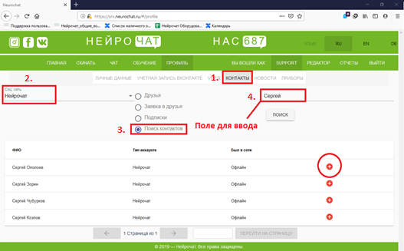
Illustration 8. Adding a contact in your friends list.
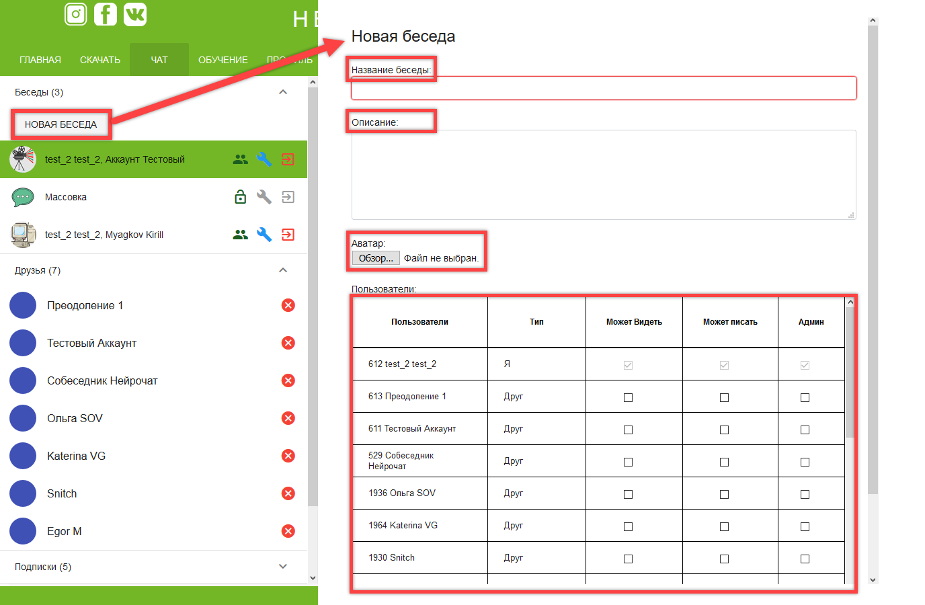
Illustration 9. Creating a group chat
To create a group chat go to the «Chat» section, then click «New conversation». In the appeared menu enter the name of the group chat, as well as its description, then add a photo and add users. Users can be assigned various rights, such as viewing, typing and managing the group chat. To assign rights ‘tick’ the box in the corresponding rights column next to the user’s name.

  - Connecting a phone number
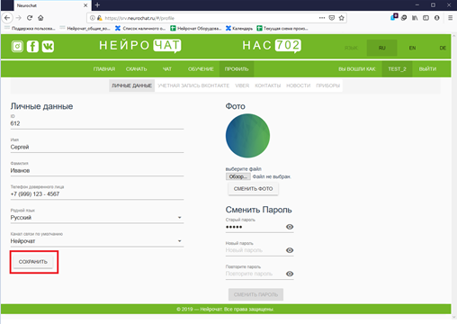
Illustration 10.Connecting a phone number
In the «Profile» section enter the phone number in the «Trustee phone number» field and click «Safe». (Illustration 10). This number will receive messages created using Neurochat, as well as alarming and informative messages from the user («I want to eat», «I want to drink» etc.). Besides, this section also allows you to add a photo and make changes in your contact information.

2.6. Network Setup
Connect Wi-Fi adapter to the computer (if there is no built-in Wi-Fi). Setup the Wi-Fi module according to the instructions of the computer software or Wi-Fi adapter.
Turn the amplifier on. To do so, insert a battery, making sure the amplifier is placed horizontally, base down. Then, lightly tap the top part of the amplifier twice until the LED is blinking green. Turning on the headset and operating instructions are discussed in detail in Section 3.
Connected to the amplifier using Wi-Fi. The name of the device begins with «EEG8_», the password is «neurochat» (enter using lowercase latin letters, as shown on Illustration 11).
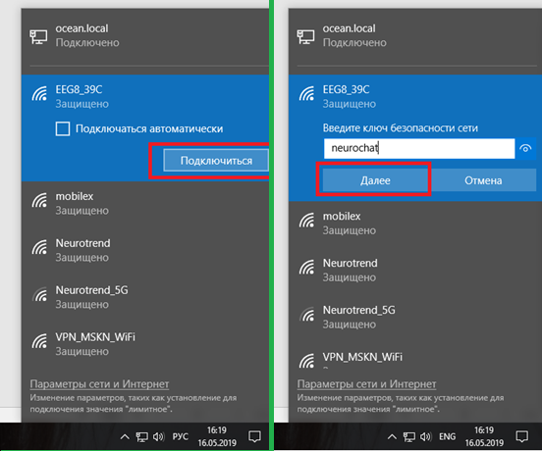
Illustration 11. Connecting the amplifier to the Wi-Fi.

IMPORTANT: When connecting the device for the first time use password ‘neurochat’.
Open «Start» and go to «Control Panel in «Utilities - Windows» tab (Illustration 12).
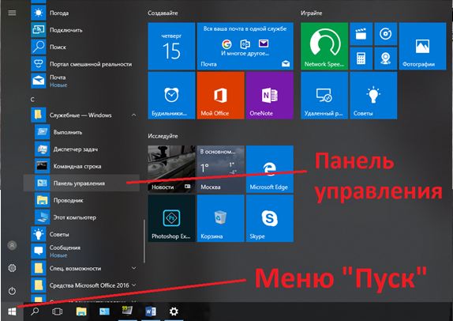
Illustration 12. «Start» menu - Control Panel
In the opened window, select the «Network and Internet» option (Illustration 13).
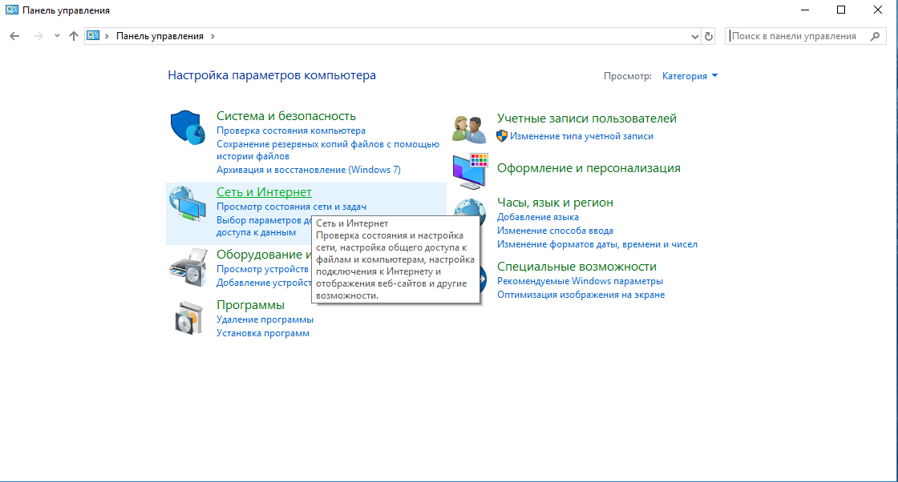
Illustration 13. Network and Internet in Control Panel
Select «Network and Sharing Center» (Illustration 14).
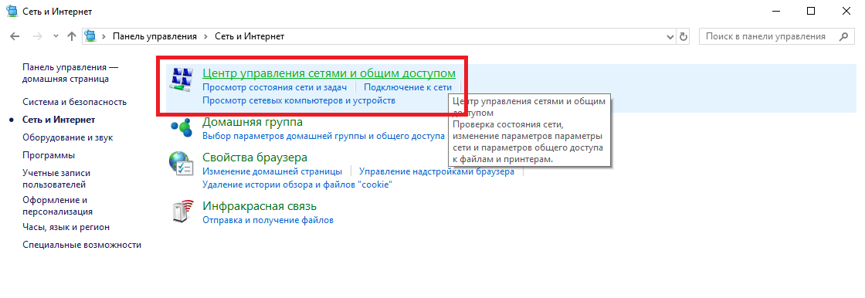
Illustration 14. «Network and Sharing Center» in «Network and Internet» tab.
In the opened window select «Change adapter settings» (Illustration 15).
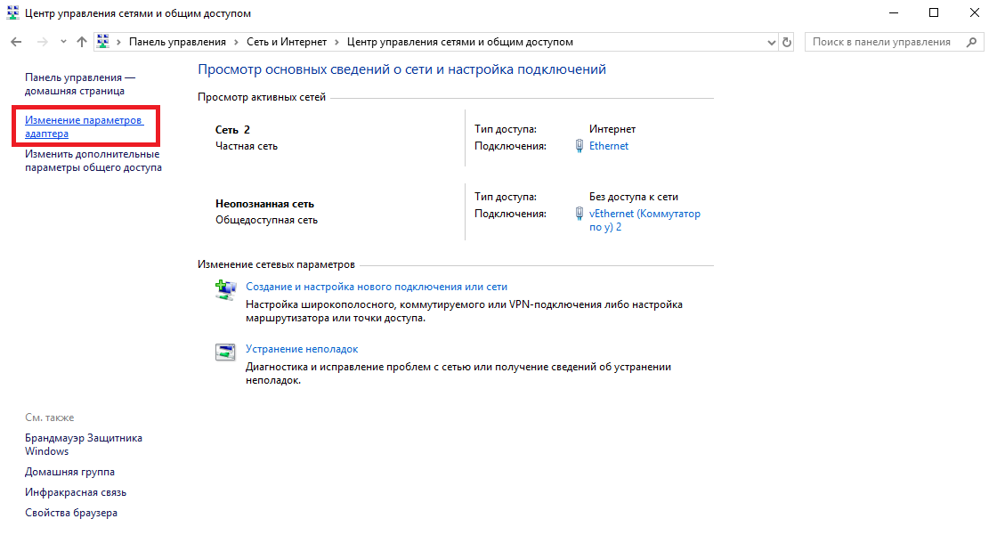
Illustration 15.«Network and Sharing Center»
Find the necessary wireless network, hover over it and right click. Then, in the appeared menu , click «properties» (Illustration 16).
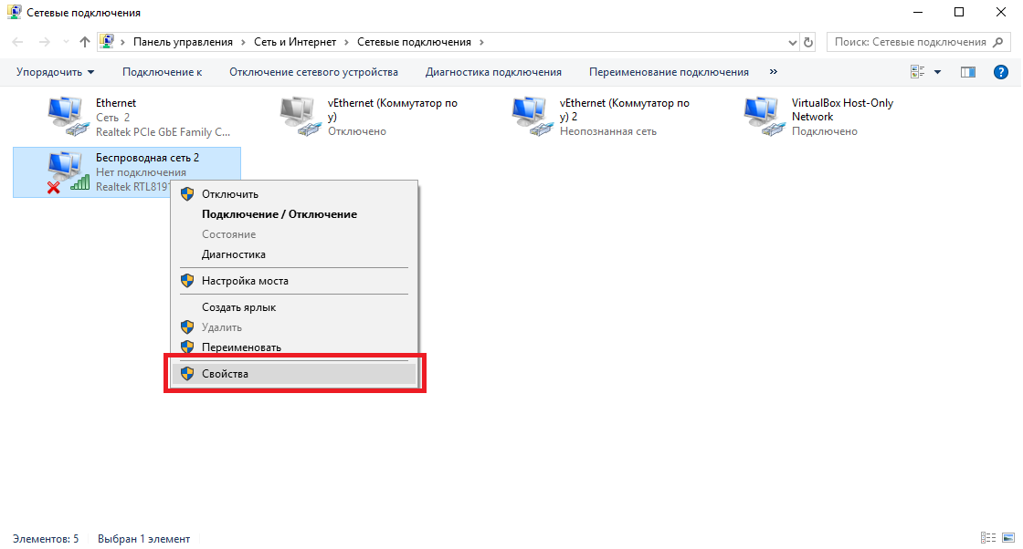
Illustration 16. Connection Properties Dialog

Select «IP version 4 (TCP/IPv4)» from the list and click properties (Illustration 17).
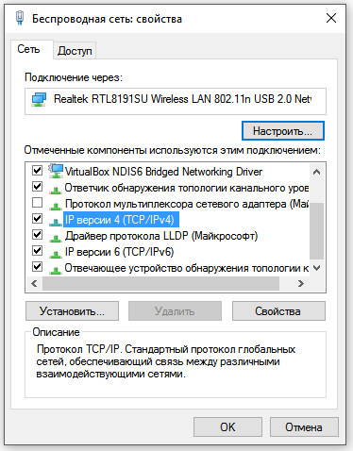
Illustration 17. Settings Dialog
Select «Use Next IP-address» and fill all the fields as shown on Illustration 18 (IP-address: 192.168.127.126, Subnet Mask: 255.255.255.252) and click OK.
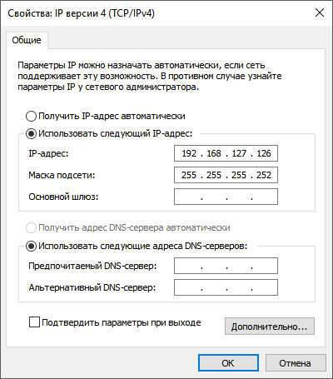
Рисунок 18. Изменение настроек IP-адреса.

2.7. Program Launch, First Time Settings
User right click to open «Neurochat» on the desktop, select выберете «Run as Administrator» (Illustration 19).
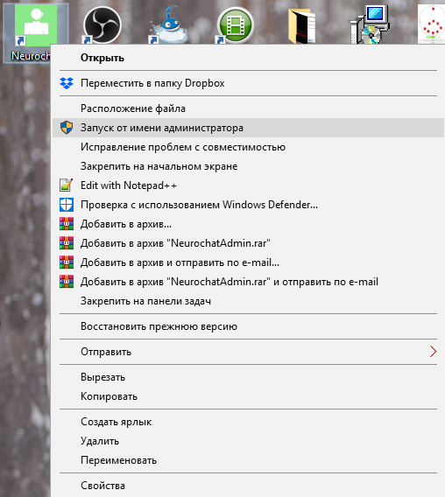
Illustration 19. NeuroChat Launch
In the top right corner select: Menu (Illustration 20) → Settings → «Main» tab or press F5 on the keyboard.
Illustration 20. EEG Info, Main Program Window
Enter following settings (Illustration 21):
username and password created upon registration (registration is described in section 2.2.);
If necessary turn off the sound notifications;
Save settings.
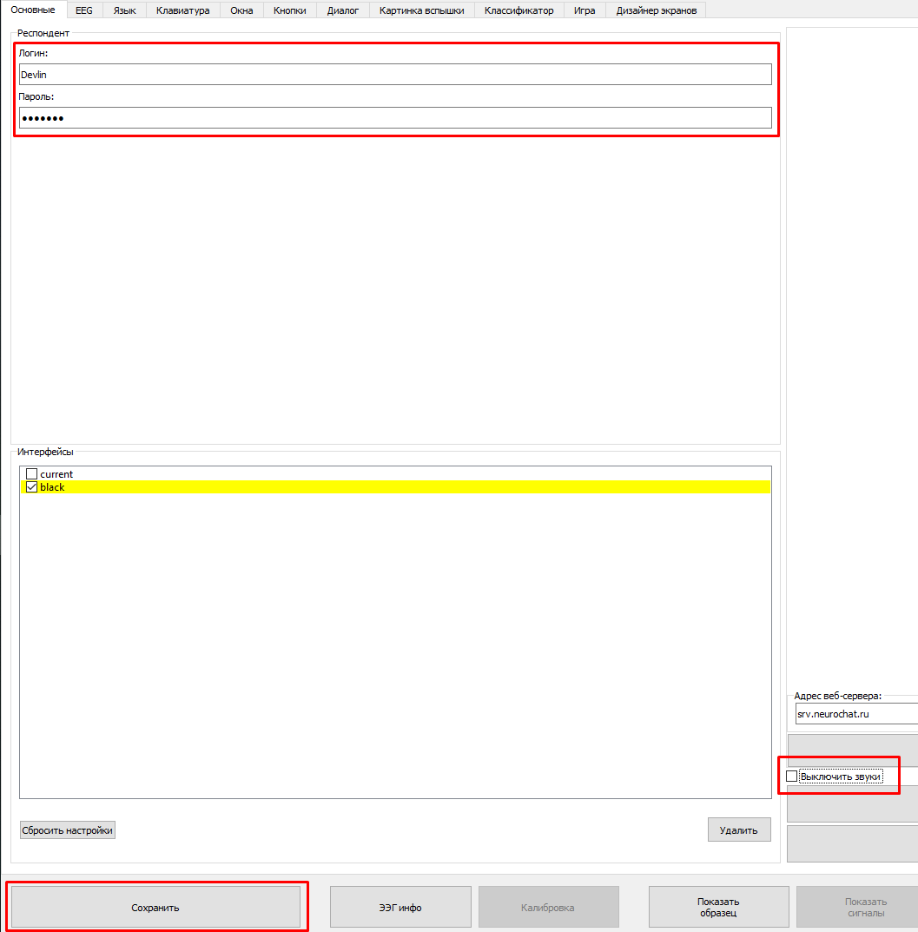
Illustration 21. NeuroChat Settings Window.

3. About Neuro-headset «GARANT-EEG»
The neuro-headset “GarAnt-EEG” consists of a headset frame with an adjustment knob, a rubber pad with electrodes, an amplifier strap and the amplifier itself. The pad is attached to the headset with the help of the corresponding holes, which should be tightened by the pegs on the headset. The amplifier strap is inserted into the groove on the front of the case, and is also fastened with the pegs with the overlay.
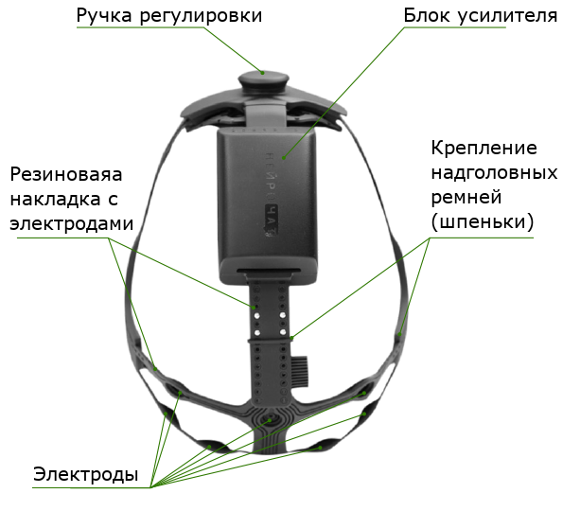
Illustration 22. Neuro-headset «GarAnt-EEG».
Нейрогарнитура имеет несколько вариантов маркировки разъёмов накладки с электродами (Illustration 23). Connector 1 should be connected to the amplifier with the marking up, whilst connector 2 should be connected with the marking facing down. The connector should be inserted into the port with little to no effort, but it also should not dangle around or spontaneously disconnect. If you reverse the type-c connector or lightly plug it in creating a poor connection, the headset will not work correctly. If connectors were plugged in with marketing facing wrongly or they were poorly inserted into the port, neuro-headset would work incorrectly.
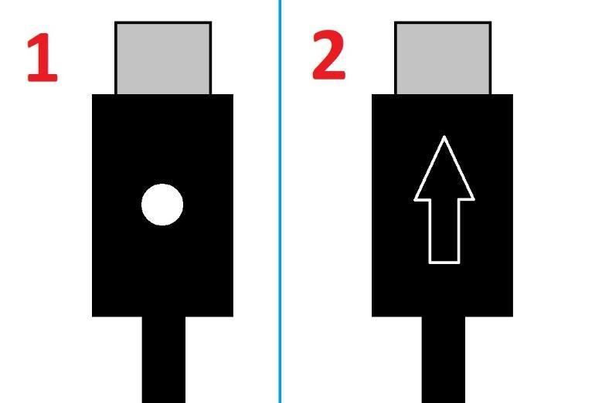
Illustration 23. «GarAnt-EEG» types of connectors.
3.1. Installing Battery
To install the battery, first remove the cover of the amplifier by sliding it through, then insert a fully-charged battery. Do not forget to insert battery the correct way following its polarity.
Put the cover back on by carefully directing it towards the grooves of the amplifier and sliding it in until it clicks, and then insert the connector with leads from the electrodes into the connector of the amplifier. (Illustration 23).
- It is prohibited to use batteries that are not like the ones, which come with the headset.
- The use of AA type batteries is prohibited.
- The use of incorrect batteries may damage the headset or lead to a malfunction.
- Do not remove the battery with sharp objects, as that may cause damage.
- Do not remove the battery from the negative lead.

3.2. Turning on the amplifier
To turn on the amplifier, place the device horizontally, face down and quickly tap it twice using your fingers or palm of your hand. If done correctly, on the top of the amplifier green LED light will start flickering meaning the amplifier is on and ready to start working.
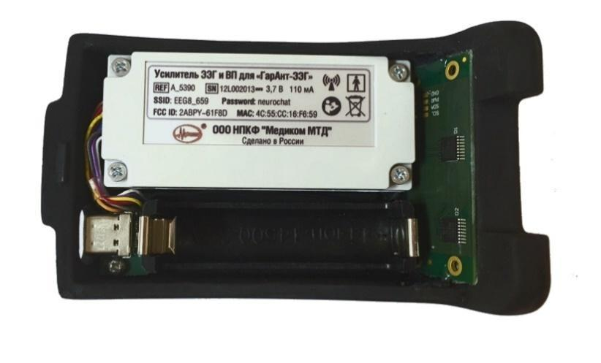
Illustration 24. Amplifier of the neuro-headset with no battery and the cover.

4. Preparing to work with the headset
4.1. Program Launch
To launch the program it is important to complete the following sequence of steps:
- Turn on the amplifier (insert the battery into the amplifier and tap the top of the device twice)
- Connect the amplifier to the commuter using Wi-Fi (name of the device starts with «EEG8_», password – «neurochat»).
- Launch the program through Neurochat desktop shortcut.
- Wait for the amplifier to connect to the program. In case it does not happen, go to the EEG tab and click «Connect EEG» (Illustration 25).
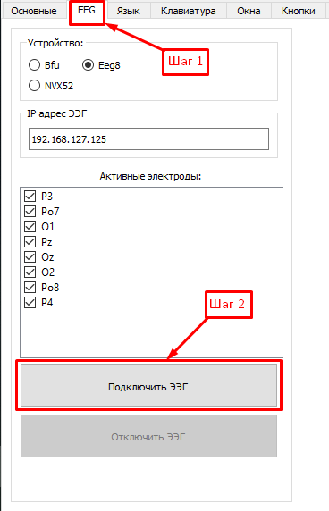
Illustration 25. Manual connection of neuro-headset amplifier.

After connecting the amplifier to the program, check if the EEG is set and connected correctly. To do so, go to the «Main settings» tab and select «EEG info». (Illustration 26).
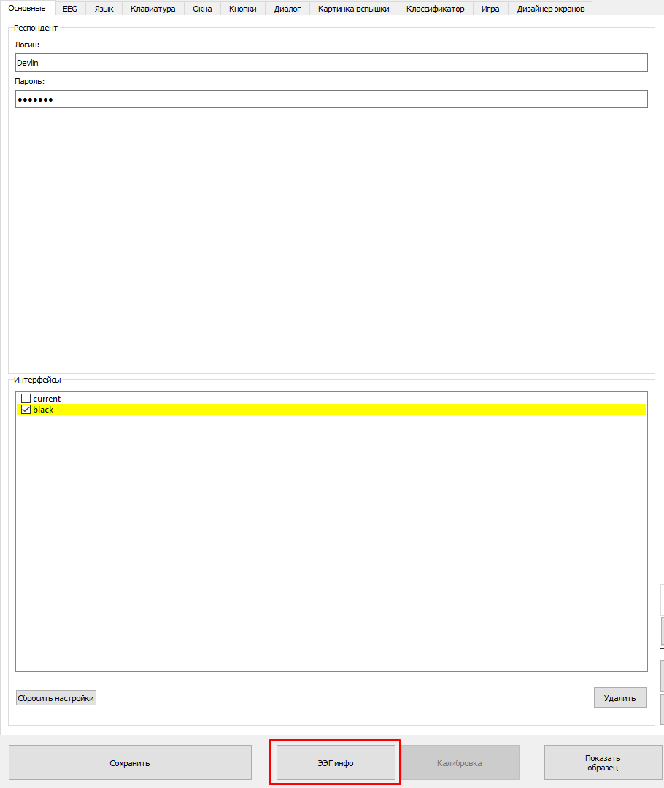
Illustration 26. NeuroChat settings window.
Check the battery if the battery in the amplifier is charged. The battery level is shown as a percentage in «EEG info» tab. In order to be able to work with the program, battery percentage should be at least 40%. (Illustration 27).
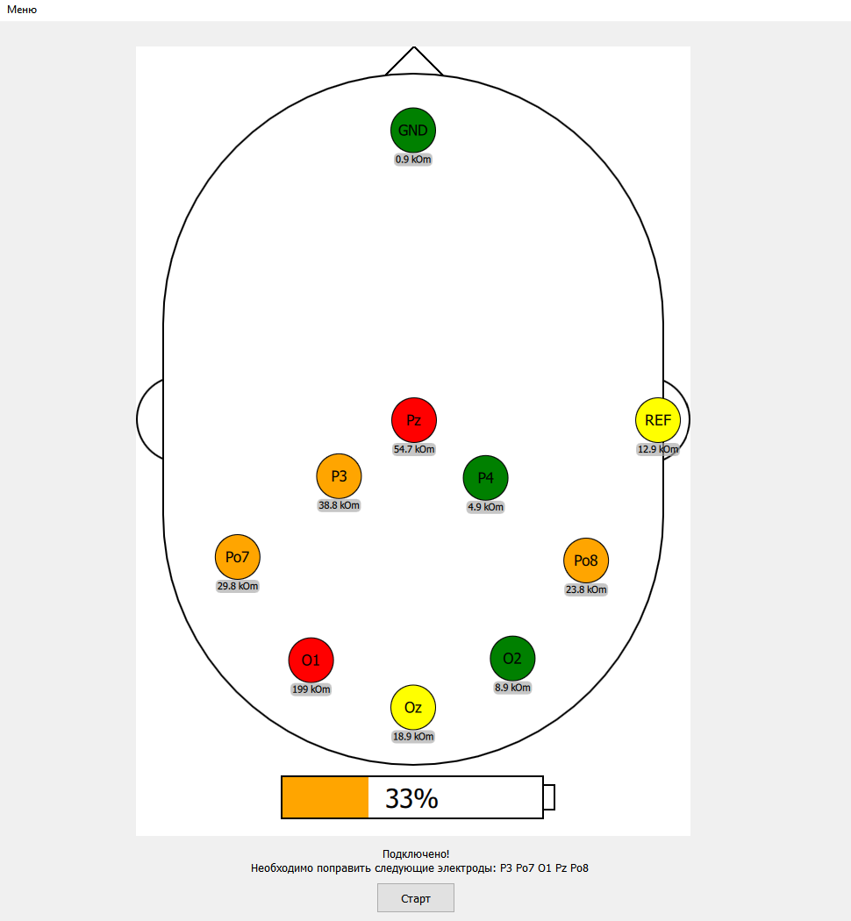
Illustration 27. Electrodes status window «EEG info».
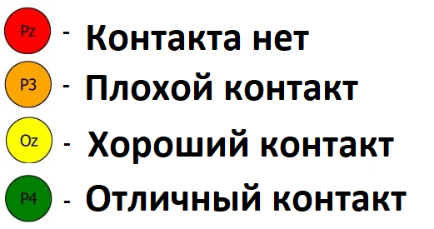
Illustration 28. Electrodes status
4.2. Installing the headset on the head of a user

Before putting on the neuro-headset on a user’s head, place the pad with electrodes on the frame of the headset using pegs. It is recommended to start from the back strap followed by side straps. Connect the amplifier to the strap and then attach it to the pad. Insert the connector of the headset into the amplifier.
Before assembly, you must bring the headset case to its smallest possible size; to do this, turn the adjustment knob clockwise until it stops. Then take the pad with electrodes and fasten it to the case with the pegs. You should start with the back strap, and then fasten the side straps. Next, install the power supply using the correct strap and attach it to the lining. Insert the connector into the power supply.
When you first put the headset on the user's head, maximize the size of the headset. To do so, twist the adjustment knob which is located at the front of the headset frame, anticlockwise. Place the headset on the user's head so that the amplifier is located closer to the frontal region of the head, and the electrodes - closer to the back of the head. If necessary, loosen or untie the hair and remove the earrings.
Make sure the neuro-headset fits the user’s head correctly; the frame of the headset has to be symmetrical to the ears. If necessary, adjust the position. Tighten the frame by turning the adjustment knob clockwise if the headset is too loose.
It is important to have the headset fit tightly enough around a user’s head. Place the pad with electrodes on corresponding mounts until the electrodes physically touch the user's scalp. Electrodes must be located as close to the scalp as possible but the amount of pressure put should not make the user feel uncomfortable to avoid any unpleasant sensations.
Secure the (REF) ear electrode on the user’s earlobe. To do so, open the clip and fill the whole with conductive gel by using the special syringe provided and then attach the clips on the user’s earlobe.
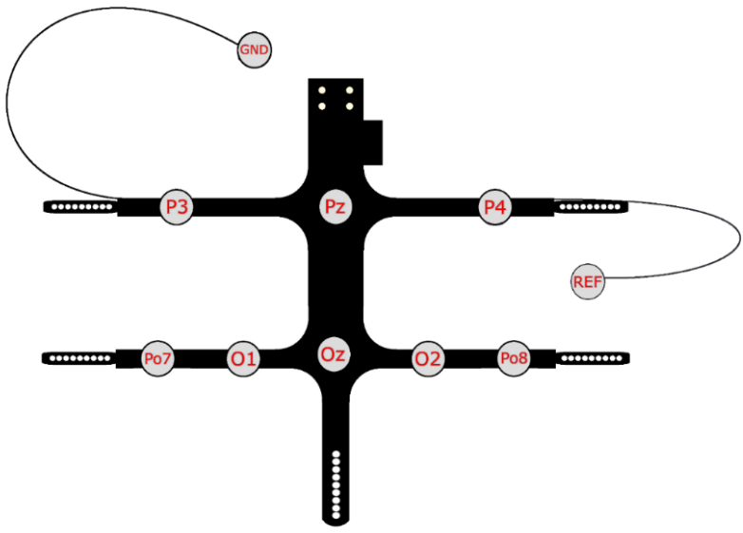
Illustration 29. Placement of electrodes on the pad with identifications of each electrode.
Add the gel inside the electrode holes starting with earlobe (REF) and frontal (GND) electrodes. For this, insert the syringe needle filled with conductive gel inside the holes of the electrodes (Illustration 30). Part the hair directly under and around the electrodes with the help of the syringe by making circular movements under an angle. Place the syringe needle inside the hole deep enough until it just reaches the surface of the head. Then, squeeze a little bit of the gel (gel can come out from the hole by 2-3mm). Repeat the procedure with all the electrodes (8 electrodes around the head, 1 near the forehead and 1 more at the earlobe). Excess gel can be removed with tissue of any kind.

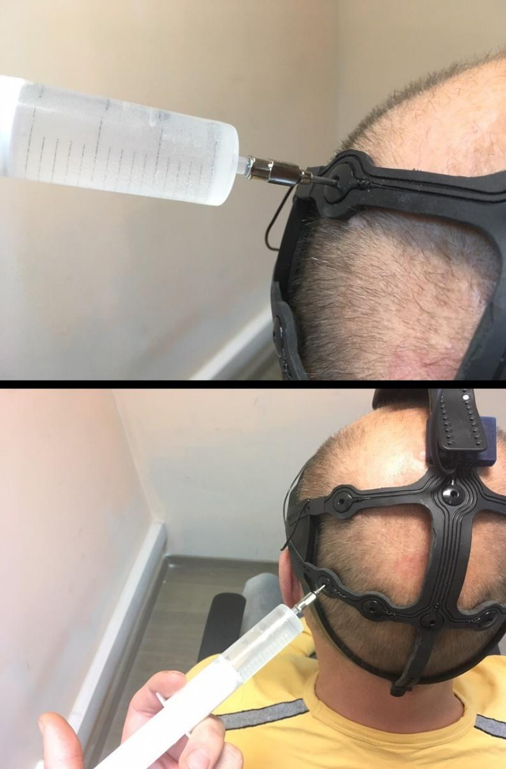
Illustration 30. Adding the conductive gel in electrode regions with the use of a special syringe.
Check the quality of connection between the electrodes and the scalp using the EEG-info tab in the NeuroChat program. (Illustration 27). It is important to achieve «good» or «excellent» connection. For that, check whether the electrodes that show either «bad» or «no contact» touch the surface of the user’s head.

Improve the quality of the signal can be done by:
- removing the hair that fell into the electrode region.
- placing the electrodes closer to the scalp by either putting more pressure or tightening the straps of the headset.
- adding more of the conducting gel either inside the electrode hole or directly under them by using the special syringe. If you see too much gel coming out from the electrode hole it is not necessary to put any more.
4.3. Calibration Guide
Prior to starting the session a user has to go through calibration first. Calibration should be done before every session after the headset has been placed on user’s head. It is also recommended to repeat calibration after a long break between sessions when the headset has already been installed (if it has been worn for several hours or more). Calibration itself takes around 7-12 minutes depending on the speed of flashes.
For calibration, select the type of the keyboard: Выберите тип клавиатуры для калибровки: alphabetic matrix or calibration with pictures (Illustration 31). Please note that when choosing a sectoral keyboard calibration will look similar to the chat keyboard.

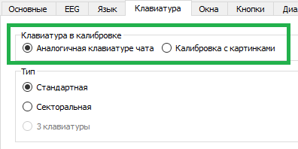
Illustration 31. Selecting a type of a keyboard for calibration.
Click on «Start» button in EEG tab (Illustration 27) or open program settings and select «Calibration» (Illustration 32).
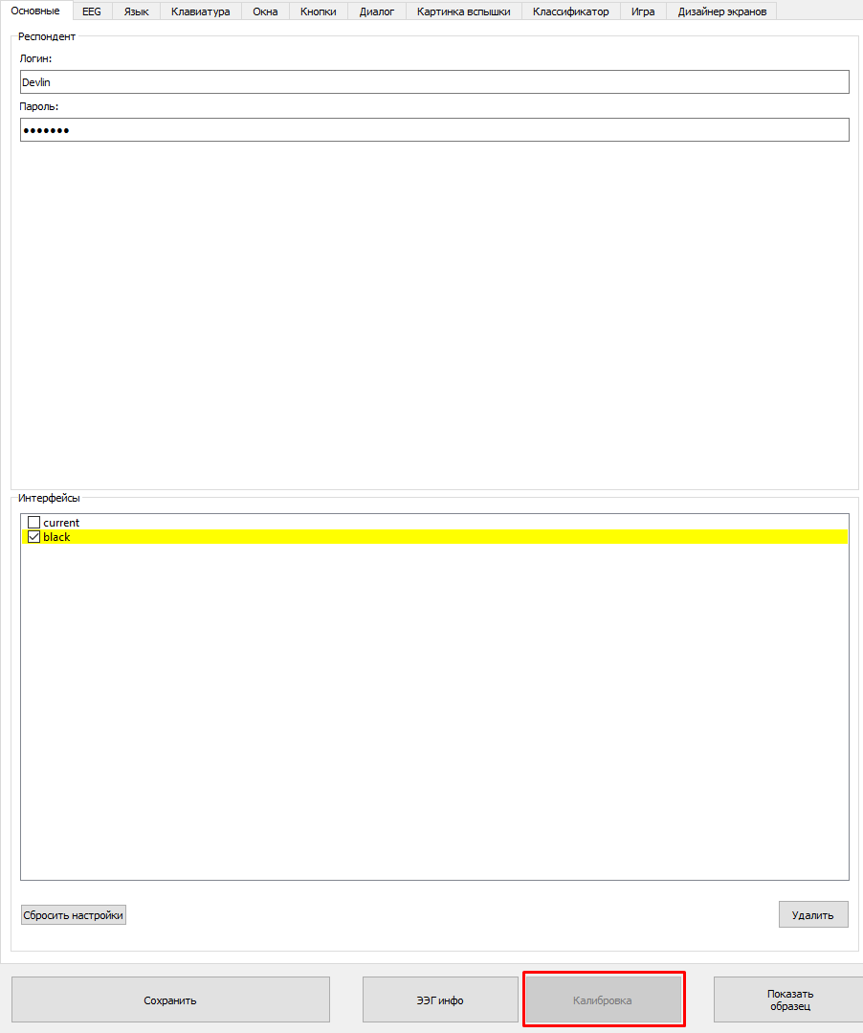
Illustration 32. Neurochat program settings window.
During calibration the frame of one of the symbols will be shown in red and the symbol itself highlighted. This symbol is called a «Target». After about two seconds the stimulation process begins. This process consists of alternating flashing (blinking) of matrix elements in a randomised order. User’s main goal is to look at the target symbol and mentally mark each time the symbol is flashing, making sure his reaction towards the target symbol in each moment of blinking is as distinct as possible.
Besides automatically counting the number of flashes appearing, it is also recommended to internally react to the symbol on emotional level in order to have a more distinct and clear reaction. When flashes for one of the symbols are over the user will be given another target (same principle with the red frame around the button), the process repeats. There will always be the same amount of flashes for each target symbol; it is important to try and mark all of them and not pay attention to other flashing symbols during the process. What matters is not just simply the counting of flashes but a clear emotional reaction to each flash of the target symbol.
IMPORTANT: Universal version of a mental reaction on a target symbol could be short one syllable words, such as «One! One! One!» or «Yes! Yes! Yes!», «Yay! Yay! Yay!». User may also use sounds instead (for example, «O! O! O!» or «А! А! А!).
Working with NeuroChat should be carried out in very calm conditions, no distractions so that the user was able to fully concentrate on the task given - give an emotional signal to the brain when counting flashes. In the room where the session takes place, it is important to ensure silence and even lighting.
IMPORTANT: When working with NeuroChat, best results are acquired in good health, high motivation and regular training.

Calibration process is an extremely important step. The better the user completes the task, the better the computer program will be able to tune in with his reaction, and the more successful user will be able to independently select commands and symbols in the program. After the calibration is finished, the program will display the calibration accuracy score. The calibration accuracy should be at least 80/30. If even one of those numbers is less than stated, it is recommended to repeat the process of calibration. If after the recalibration the second number is lower than 30, user could try working with the program, although it is recommended to try calibration again until the second number is no lower than 25.
When the calibration is completed successfully, the user can begin working with the main program. Regardless of how the symbols and their flashes are organized on any of the application screens, in order to select the next command, the user must do the same thing as at the calibration stage, that is, internally think about highlighting the desired command symbol very clearly and intently.

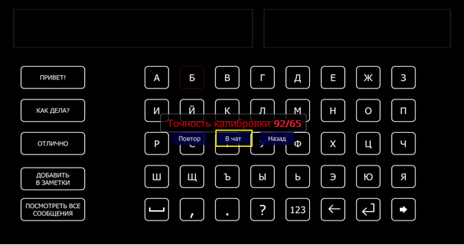
Illustration 33. Calibration Results.
When the calibration is finished select «back», «chat» or repeat calibration once more. If При нажатии кнопки «chat» is selected, user will be automatically transferred to the starting chat window (section 5.1.). Нажатие кнопки «Back» brings the user to the program menu where he can change settings and continue working or restart the calibration.
4.4. Keyboard Settings, types of flashes
The highlight speed and the type of keyboard can be adjusted based on the individual preferences, which can be found in the «Keyboard» tab (Illustration 34). Reducing the speed of flashes is recommended when the patient has trouble keeping up and responding to the highlighting of the target character. Lower speed of highlights causes the calibration process to slow down.
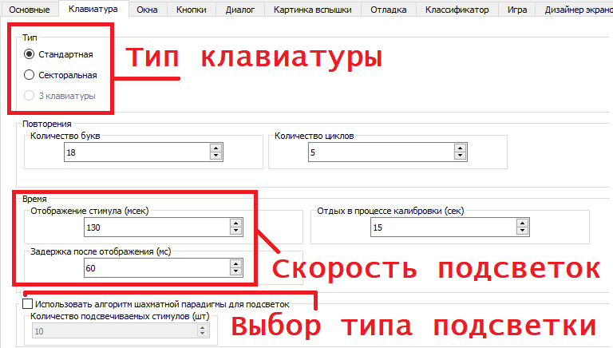
Illustration 34. NeuroChat Settings Window.
The speed of flashes is regulated by the «Stimulus Display (ms)» and «Delays (ms)» parameters . Recommended values: 160/80. In the case of unsatisfactory calibration results (when the patient is not able to keep up and count the flashes of target stimuli), the values ​​should be set to 150/80 or 180/80.
To type, the standard or sectorial alphabetic keyboards can be used. The advantages of the standard type: clear control, adaptive typing, higher typing speed compared to the sectorial matrix. Instead of the standard algorithm, you can also use a chessboard illumination algorithm. To select, change the amount of letters to 10 instead of 18 in the «Keyboard» tab, and the amount of cycles should be changed to 10 instead of 5 by default (Illustration 34).

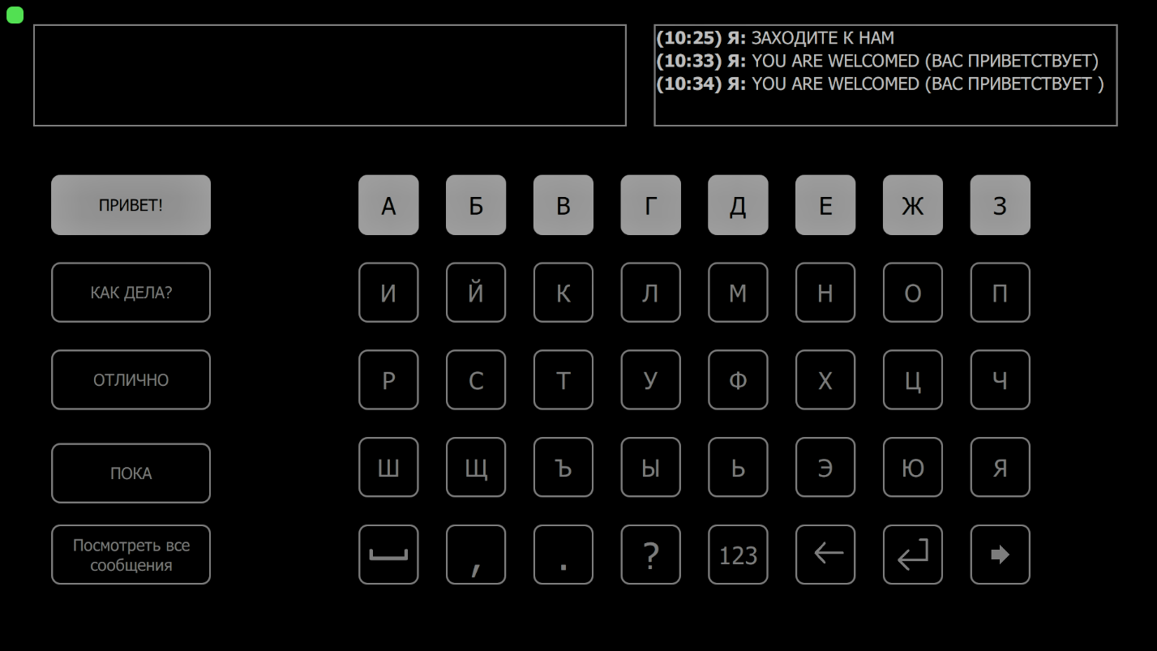
Illustration 35. Standard Keyboard, linear flashes.
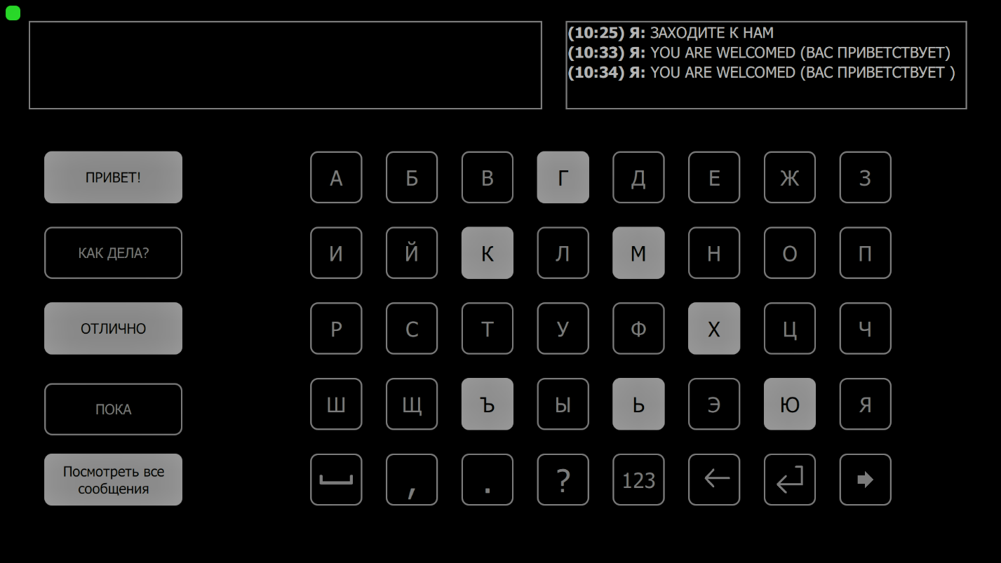
Illustration 36. Standard Keyboard, chess flashes.
The use of the sectorial matrix (Illustration 37) is recommended for users with visual impairments: it is less tiring to view and is aided by high selection accuracy due to the small number of stimulus cells. If necessary, you can also reduce the speed of the flashes.
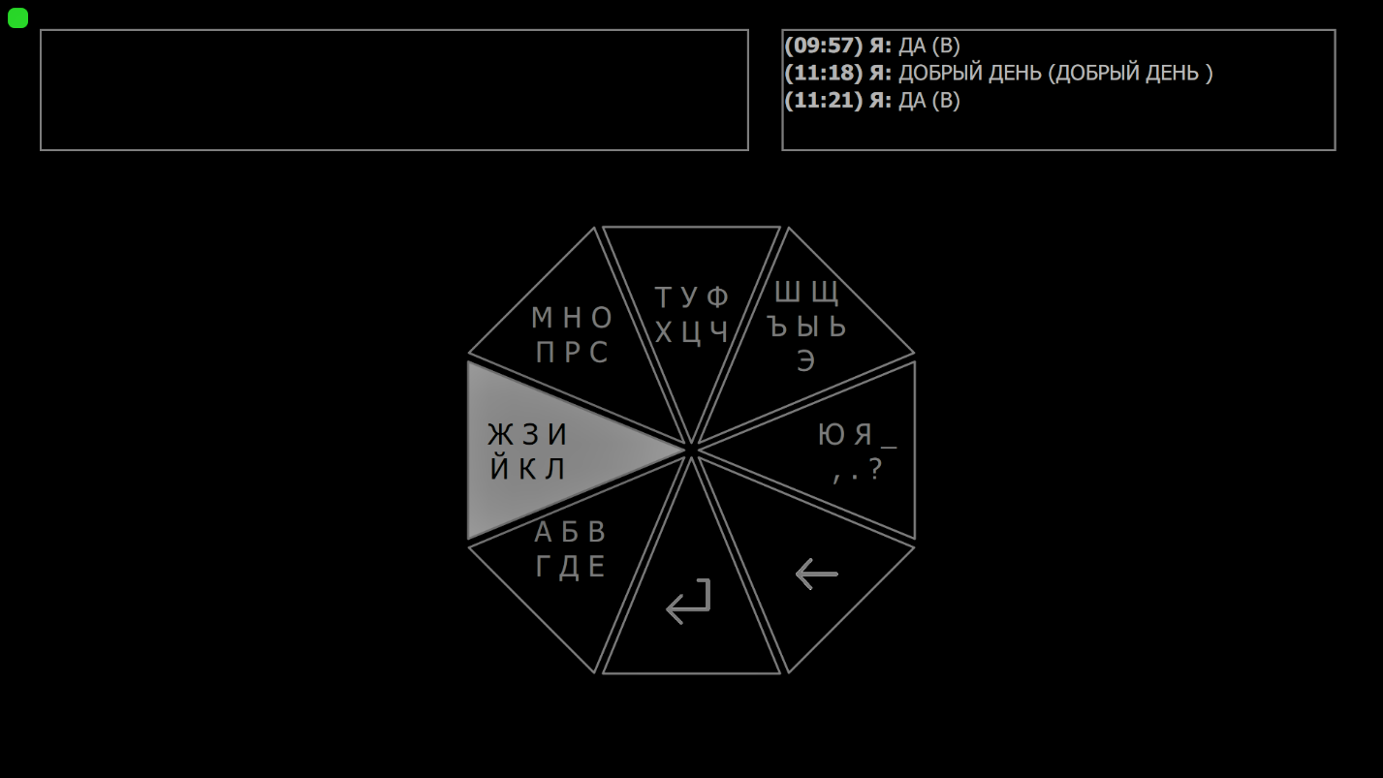
Illustration 37. Sectoral Keyboard.

5. System Operations
5.1. Client Startup Window
Connection to the server is displayed in the upper left corner (Illustration 38). Its color indicates the connection status.
- Red - no connection. Internet connection should be checked
- Orange - connection in progress.
- Green – connected.

Illustration 38. Startup Window
The total number of unread messages is displayed to the right of the connection indicator.
From the start window, the user can control the program using two buttons. At this stage, as well as further in the process the control over symbols is based on the principle of cognitive reactions on the highlighted symbol of letter.
- go to the main screen of the program.
- alert message.
When this button is triggered, the message «Alert!!!» appears on the screen (Illustration 39).
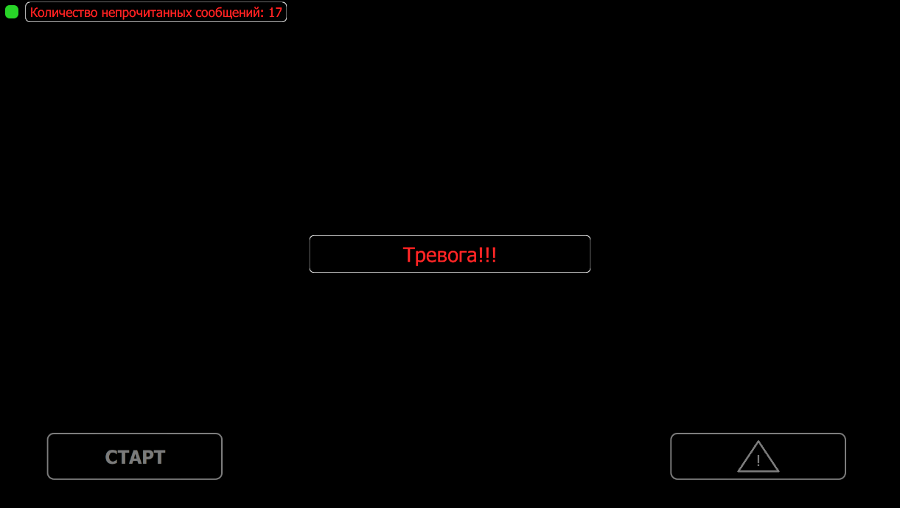
Illustration 39. Alert message.
If there is an associated mobile phone number, an SMS notification will be sent to this number, with the same text.

5.2. Main Menu
The main menu of the program opens after selecting the “Start” button in the start window of the program (Illustration 40).
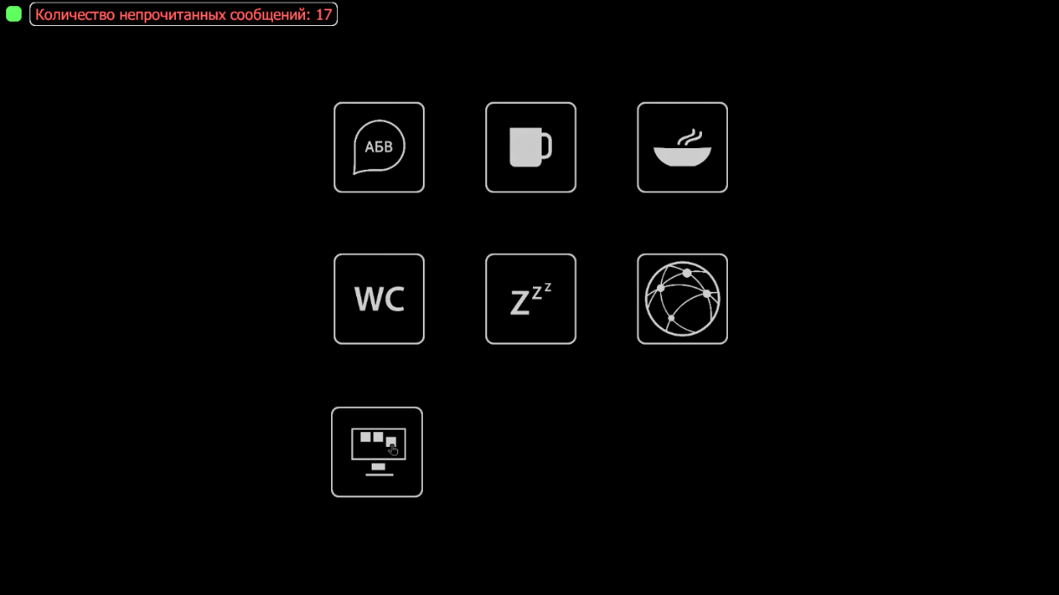
Illustration 40. Main Menu.
This screen contains main program functions for the client:
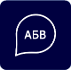 - contact window (section 5.3)
- send message ‘I am thirsty’. The message will be displayed on the screen. Выводит сообщение на экран (Illustration 41).
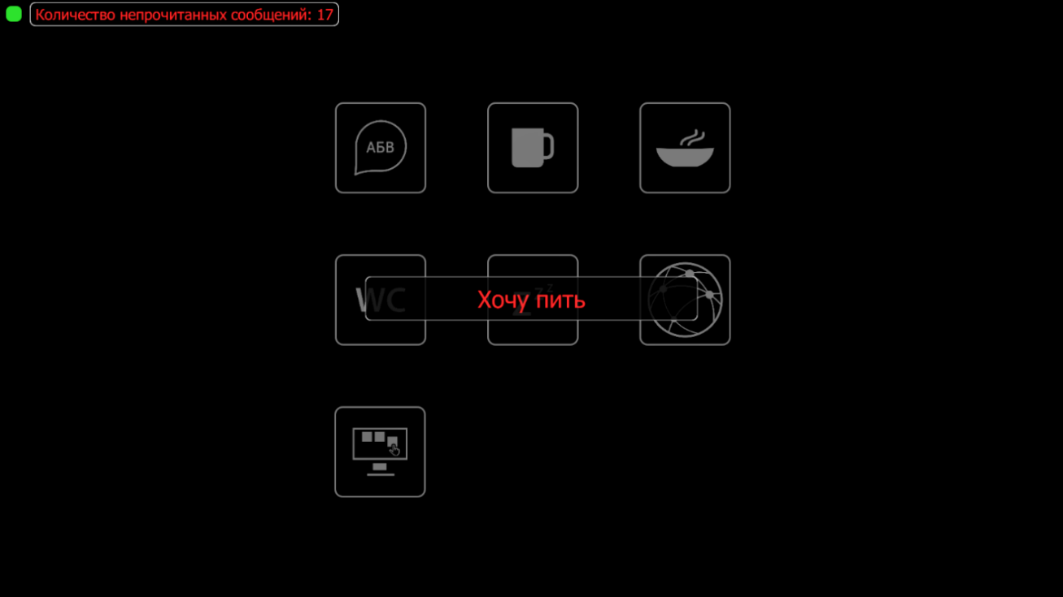
Illustration 41. ‘I am thirsty’ message.
If there is a phone number connected to the program, the notification will also be sent to the number with the same text.
- send ‘I am hungry’ message. Displays a message on the screen, and also sends SMS to the connected mobile phone number.
- send a message about needing the bathroom. Displays a message on the screen, as well as sends SMS to the connected mobile phone number.
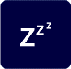 - back to the start menu (section 5.1)
- information channel (Illustration 42)
- go to customization of windows (раздел 9).
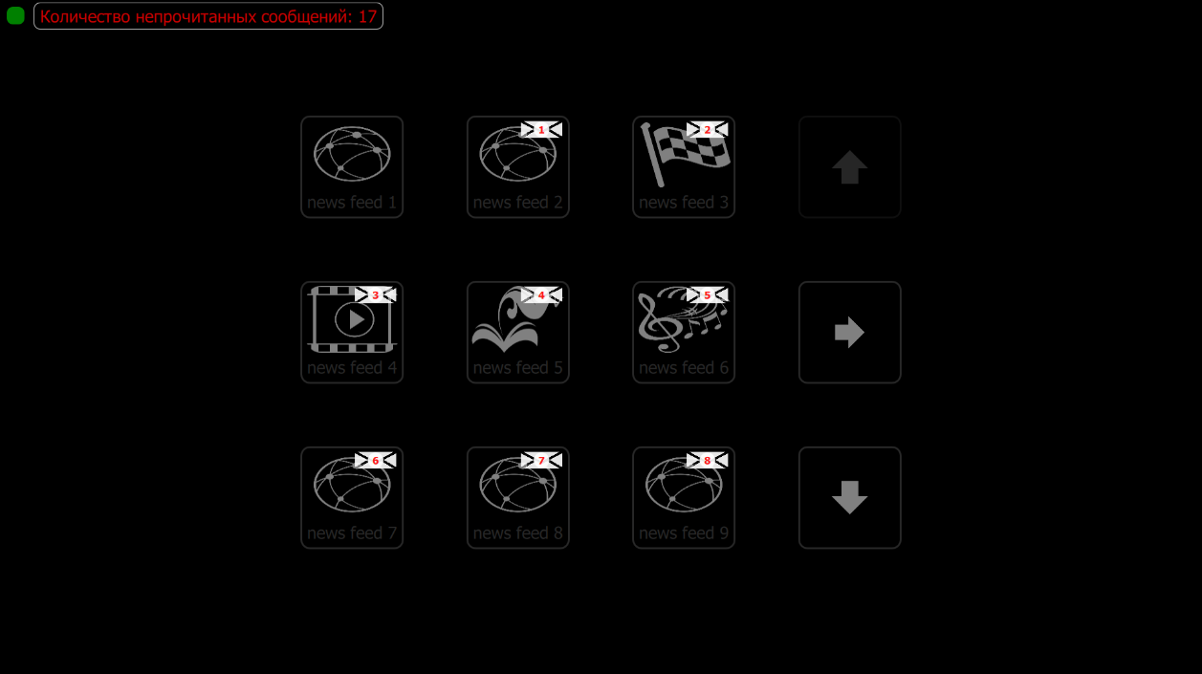
Illustration 42. Information channels.

5.3. Contact selection window
The contact selection tab is accessed from the main screen of the program when you go to the contact tab 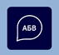, which shows a list of available contacts (Illustration 43):
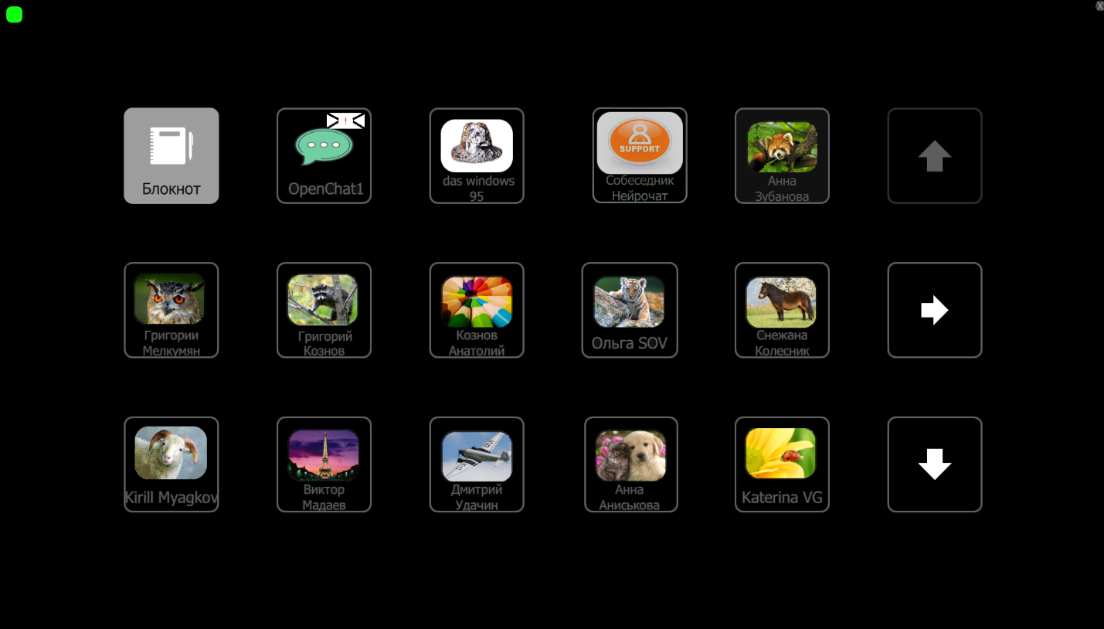
Illustration 43. Contacts window.
When you select one of the contacts, the chat window opens automatically. Add contacts described in detail in section 2.4.

5.4. Chat Window
Using chat window (Illustration 44) the user is able to chat with the chosen contact by typing a message.
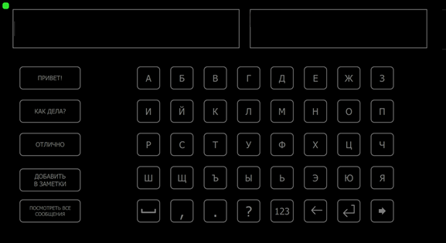
Illustration 44. Chat Window

The typed message is displayed in the upper left corner of the chat window - in the typid field.
To the left of the letter matrix there are 4 speed dial buttons. They allow speed typing of key phrases used for interaction (“Hello!”, “How are you?”, “Excellent”). When typing a message, these buttons are adaptive - the program offers options for ending words and phrases for letters entered by the user, using a dictionary of the most frequently used words .
In the upper right corner the message history is displayed, consisting of the last three lines of messages. To view all messages, select the button. “View all messages", which is located under the speed dial buttons in the lower left hand corner.
In the current HSC version, communication is conducted with only one contact at a time. Messages from other contacts are saved, but there are no ‘new message’ notifications. To view these messages, the user must go to the contact selection window. (see. section 6.4) and select the contact from there.
When typing a message, the method is similar to the calibration — user needs to count the number of highlights on the target character. The difference is that now the user must independently choose the target stimulus. The user needs to find the desired cell on the screen and mentally mark the moments of its highlights until the letter appears in the typing field.
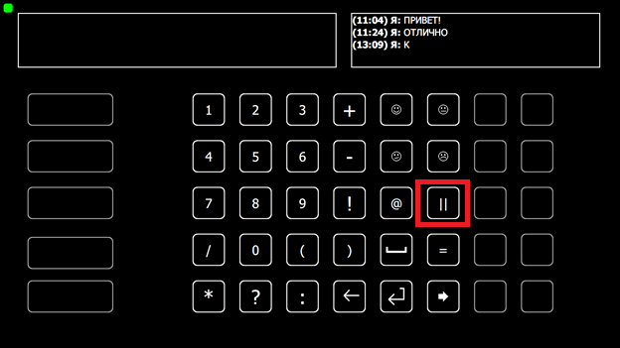
Illustration 45. Chat Window, Number Keyboard.
To use numbers (Illustration 45) select 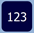 button in the chat window (Illustration 44). Screen with numbers can be paused by selecting two vertical lines (3rd cell in the bottom right corner). To exit the sleep mode go to section 5.7.
In the case of a selection error, the user can delete the unnecessary character from the message string. To do this, select the button .
to send a message select .
To go back select .
If there is no activity in the program for a certain time, the comeback to the main menu occurs.

5.5. Message Window
Message window shows all the messages with the chosen contact. (Illustration 46).
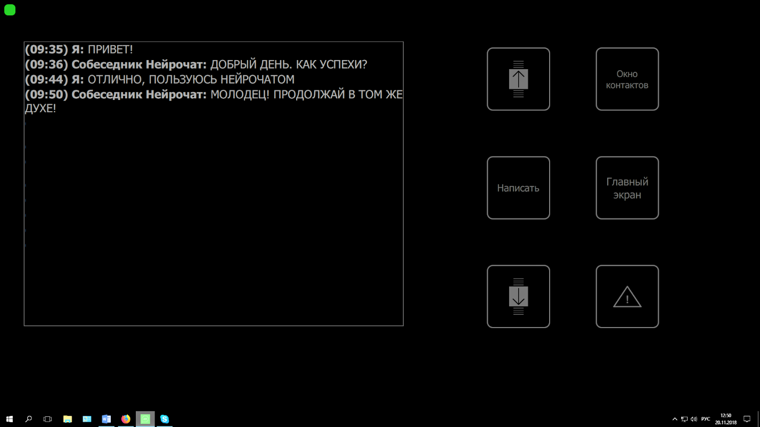
Illustration 46. Viewing messages with a chosen contact.
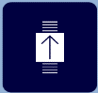 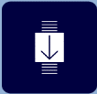 - responsible for rewinding message history.
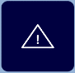 - sends an alert message (similar to the alert button of the start window) by showing it on the screen as well as sending a message to the attached phone number.
«Contact window» button brings a user to the contact selection menu. (section 5.3).
«Type» button opens the chat window (section 5.4).
«Main menu» button brings a user to the main menu of the program (section 5.2).

5.6. Notepad
Notepad allows the user to save typed text, which can later be used to send a message or save to a txt file.
To use a notepad, type the text in the chat window and then choose the “add to notes” button to save it, or press the “new note” button through the notes window. (Illustration 47).
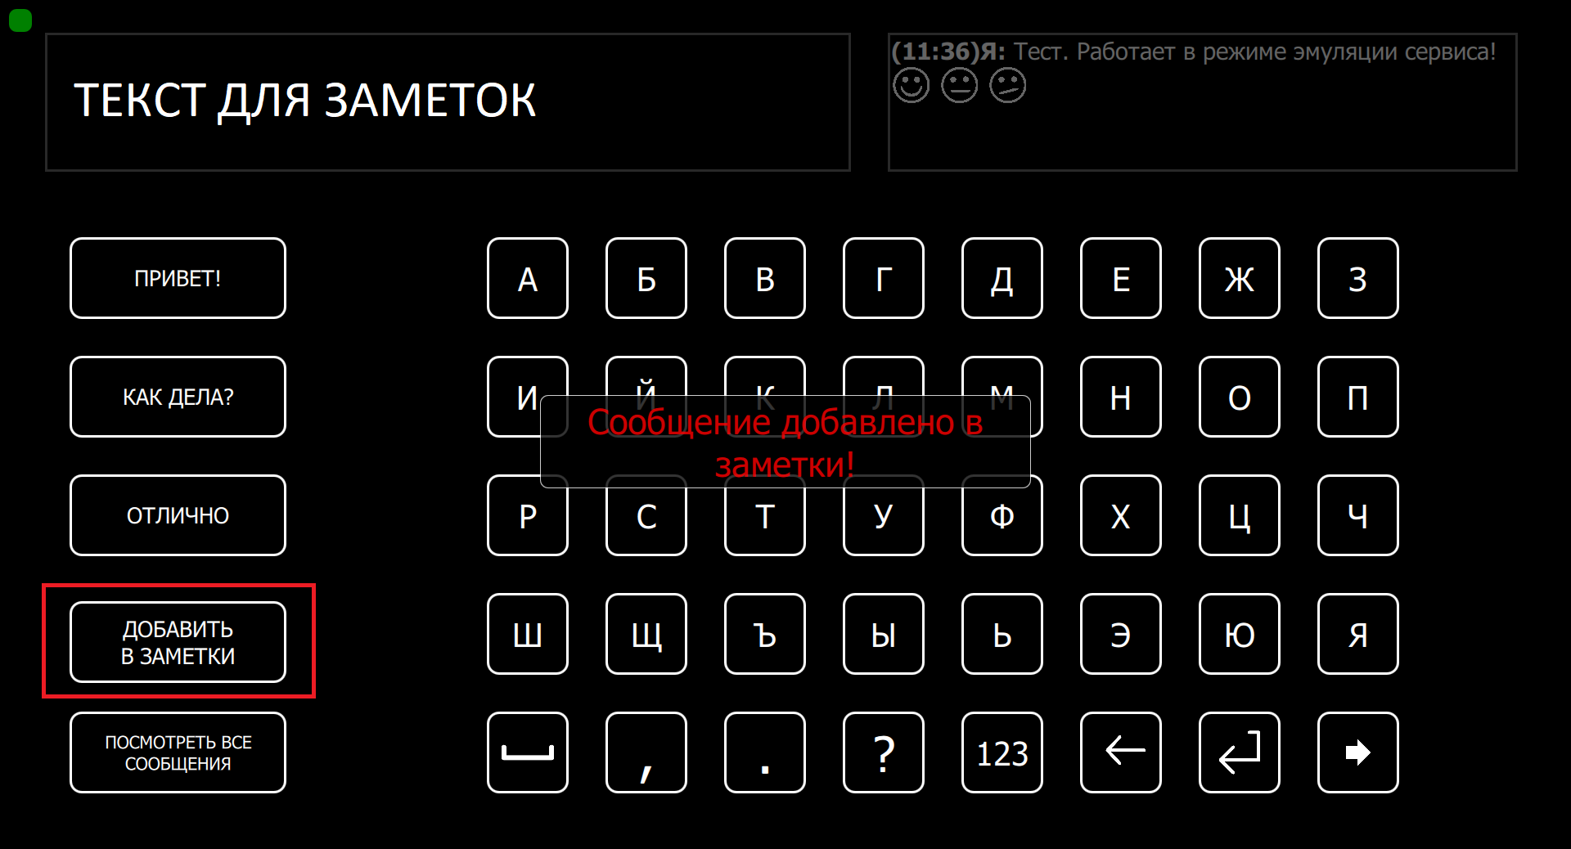
Illustration 47. Adding text to the Notepad.
To view added notes in the contact window (Рисунок 48) select «Notepad» button.
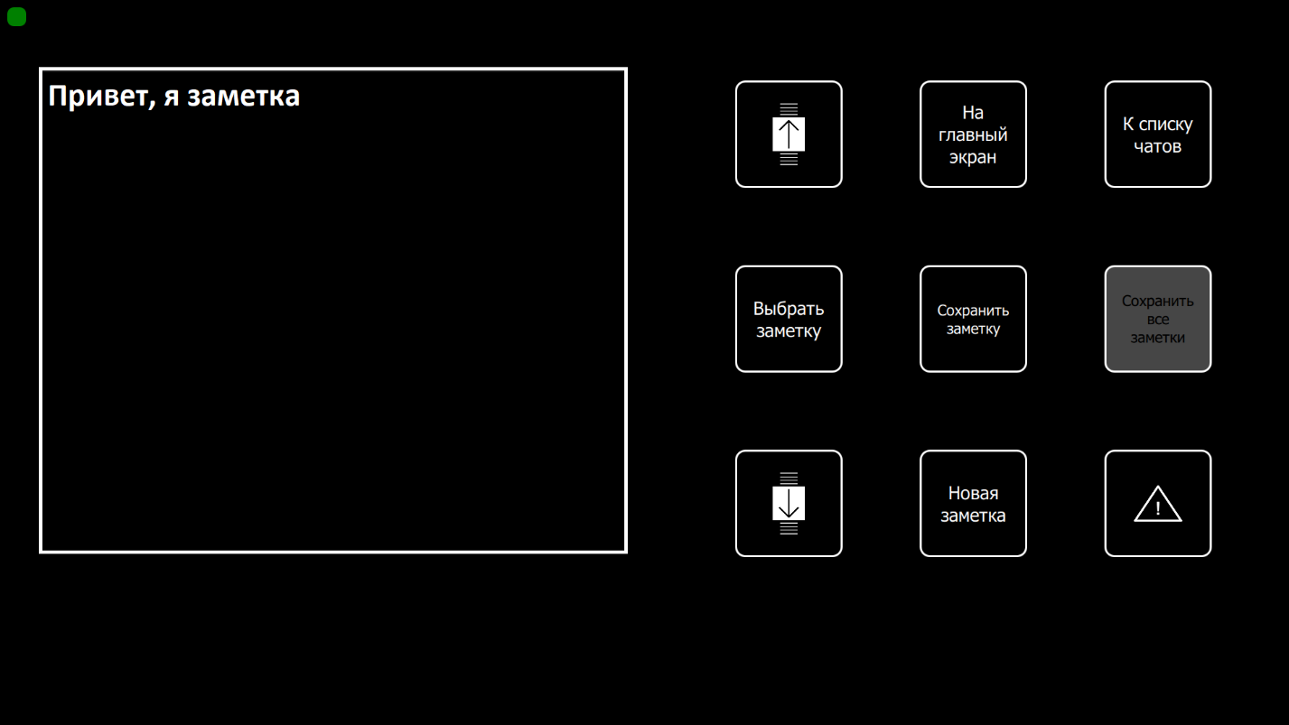
Illustration 48. Notepad.
To send a note click «select note». The program automatically goes to the contact window to select the contact the user wishes to send a note to. In the contact menu, user can also select «notebook» to continue typing in one of the existing notes.
To save a selected note in a file click «save note» or «save all notes». These notes will be saved in .txt file under the «SavedNotes» folder (default folder: C:\Neurochat\SavedNotes). The name of the file will include the date the note is saved. For example:
C:\Neurochat\SavedNotes\note_2019.03.08___14.32.11.txt.
5.7. Sleep Mode
The program goes into sleep mode and blocks and random selections if it recognizes inaction or the inability to determine the character selected by the user in 1 to 15 minutes.
You can also enable the sleep mode manually by pressing the «Pause» button or by choosing the appropriate symbol on the keyboard. (Illustration 45)
To exit sleep mode, the user must click the «unlock» button (Illustration 49), after which a confirmation screen appears (Illustration 50), where the user should click the «continue to work» button.

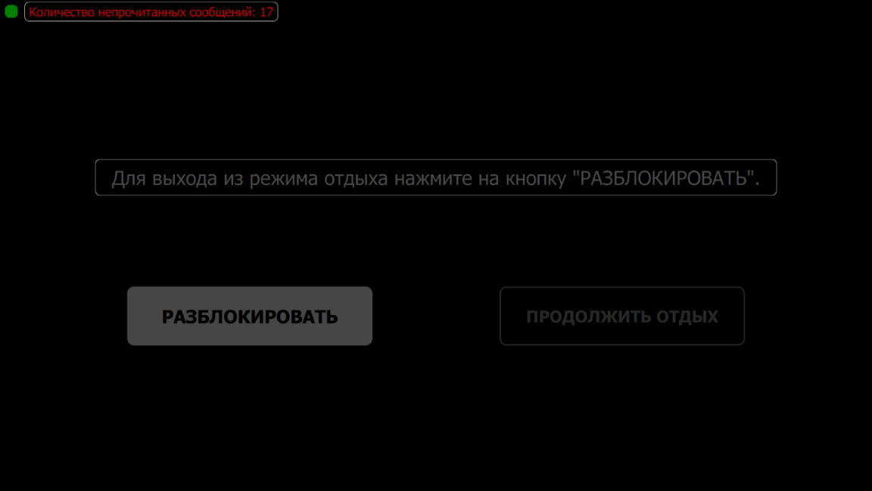
Illustration 49. Lock screen.
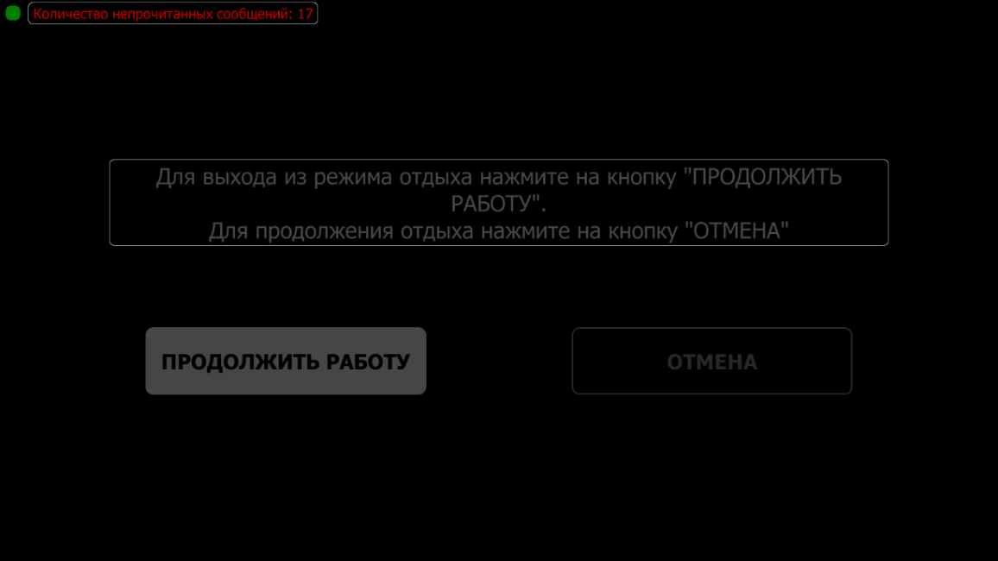
Illustration 50. Exit lock mode.

5.8. Finish working with neuro-headset.
When the user is done using the neuro-headset gently remove it from his head. To do so, loosen up the frame by turning the adjustment knob anticlockwise. After that, remove the remaining gel from the head of the user.
Amplifier turns off automatically in 10 minutes after disconnecting from program NeuroChat.
When the headset is taken off, take the amplifier, remove the battery and put it on charge.
5.9. Cleaning and Disinfecting Neuro-headset.
After using the headset it is necessary to clean the gel immediately until the electrodes are dry. If you do not do this, gel will form a non-conductive film on the surface of the electrodes. To remove the film you can submerge the electrodes in water for an extended period of time. Under no circumstance should you remove the dried film with force in order to avoid damage and destruction of the electrode contact area.

5.9.1. Step-by-step Cleaning Guide
If there is minimal residue left, remove it from the headset and electrodes with a cotton wipe or swab moistened with water or alcohol solution.
If there is a large amount of gel on the surface of the headset and inside the electrode sockets, it is recommended to wash the headset using the following the instructions:
- Disconnect the connector from the amplifier, then remove the amplifier and tighten the headset to its smallest size.
- Disconnect the pad with electrodes from the headset frame.
- Wash the pad with electrodes under a stream of water making sure the connector doesn’t get wet

IMPORTANT:
It is prohibited to wet the connector!
- Use cotton swabs to remove the remaining gel from the inner part of the electrodes.
- Use wet wipe or a tissue to clean the headset frame.
- Wash the headset. Then place it on a towel or a tissue to let the water drain.
- Let the headset air dry in a place where the water is not able to get inside the connector.
IMPORTANT:
Do not use a hairdryer or other devices that create a stream of hot air.
Do not place the headset under a direct sunlight.

If the water got inside the connector, remove it immediately using dry tissue.
In case the connector or amplifier have gel stuck to them, remove it immediately using wet wipe first, followed by dry tissue.
5.9.2. Disinfecting the Headset.
The headset should be disinfected before being installed on another user, after cleaning and drying the headset.
Disinfection of the product is carried out using isopropyl alcohol. For disinfection, it is necessary to wipe the entire surface of the headset, as well as the body of the electrodes with a cotton swab or a cloth dipped in the disinfectant solution.

IMPORTANT:
Improper maintenance may result in damage to the product. Do not use abrasive material when cleaning the product.
Do not use strong disinfectant solutions, for example, solutions based on acetone or active chlorine.
Take precaution with the contact point of the electrodes when cleaning: do not pull or strain them.

NOT ALLOWED:
Store the headset and electrodes in water or disinfectant solution.
Allow water to enter the power supply body and the contact point of the electrode connector.
Use hot sterilization methods (e.g. autoclave), as this may damage the insulation of cables and electrodes.
Chlorinate electrodes, as this will lead to corrosion.

6. Emergency Situations
6.1. No Signal (EEG is not responding)
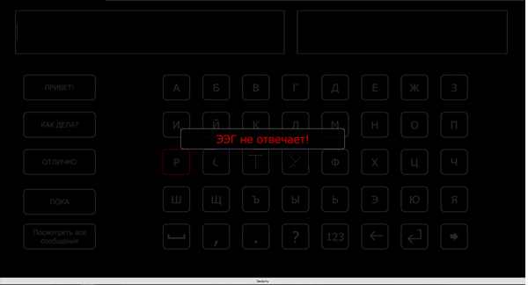
Illustration 51. Message «EEG is not responding».
If while working with the program this message appears (Illustration 51), that means that the program stopped receiving signal from the amplifier.
To solve:
- check the Wi-Fi connection
- check the connection to NeuroChat program
If there is a short break of the signal, in 30 seconds the headset will self-reconnect to the computer, and you can continue working without any further actions. If this does not happen, check the Wi-Fi connection. (Illustration 52).

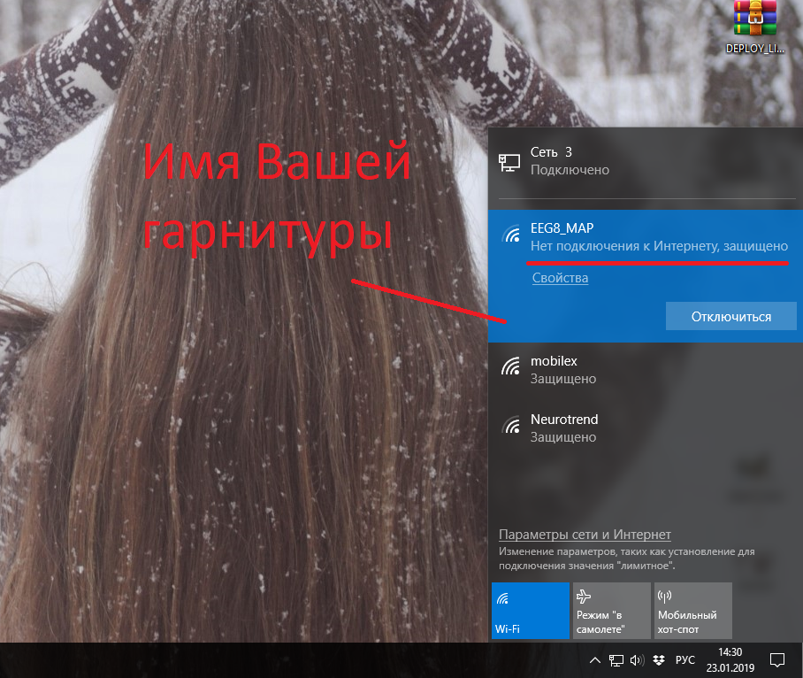
Illustration 52. Checking Wi-Fi connection.
If the headset does not establish a connection to the software and\or does not connect to the Wi-Fi, check the battery charge.
In case methods above do not work, check the software of the Wi-Fi connection or call Tech Support.

6.2. No Server Connection
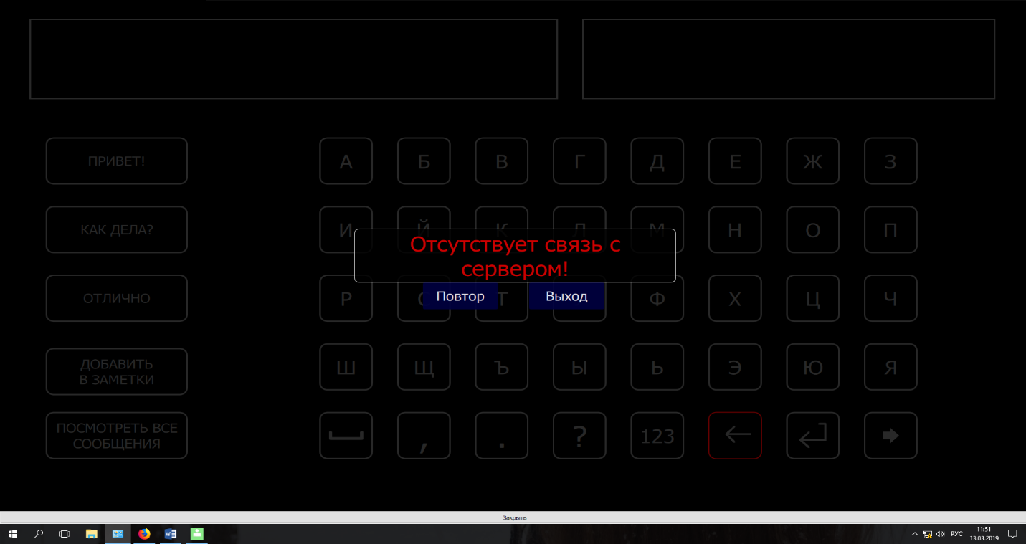
Illustration 53. «No Server Connection».
If this problem appears, check the internet connection. Try to open the site neurochat.pro website. If the page does not open, try to restart the router and computer. Otherwise, contact your service provider or your system administrator.

6.3. Message «Waiting for Calibration results…»
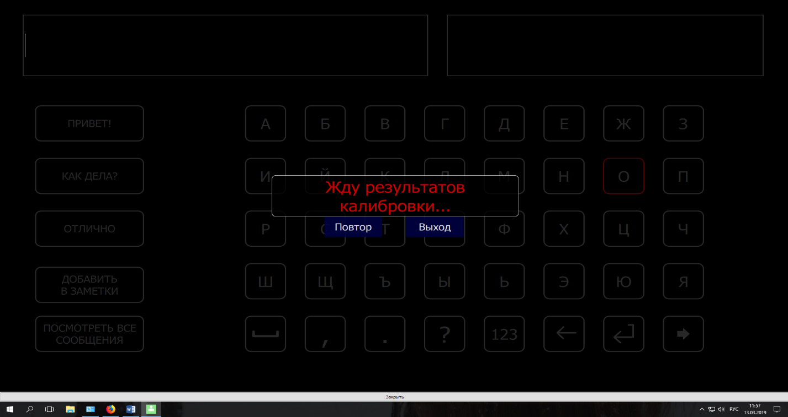
Illustration 54. «Waiting for Calibration results».
When this error occurs, check your network connection and baud rate. You can find the delay in the program in the «classifier» tab, as shown in (Illustration 55).
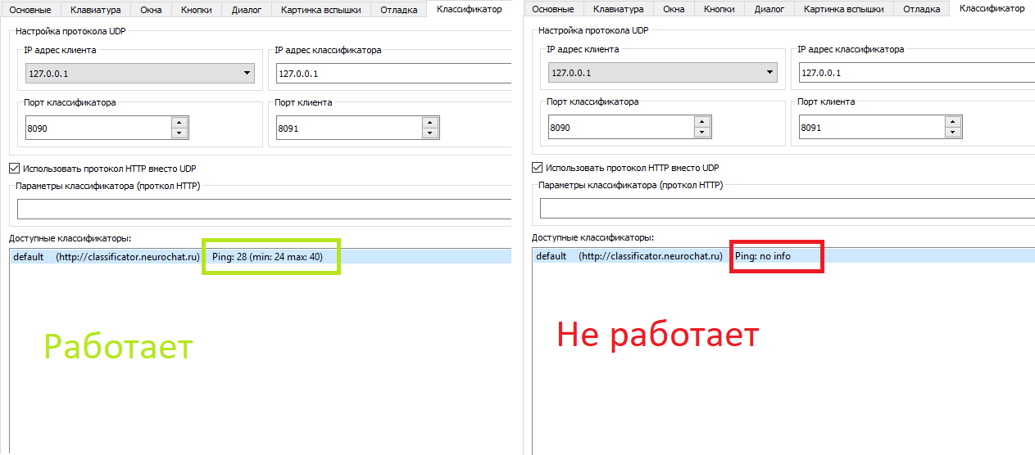
Illustration 55. Checking Internet Connection in «NeuroChat».
In Illustration 55, there are certain values written on the left. «NeuroChat» works if these values ​​are less than or equal to 150. For large values, “no info” will be written in the “ping” column, as seen on the right side of the Illustration 55. If you are using a proxy or Vpn, contact your system administrator. Otherwise, you need to find another internet connection option that provides a connection with a speed of at least 10 Mbps.

6.4. Message “Connection issue with the following electrodes” with a sound notification
When one or several electrodes do not work properly when you already started working with the program, you will see the following message (Illustration 56):
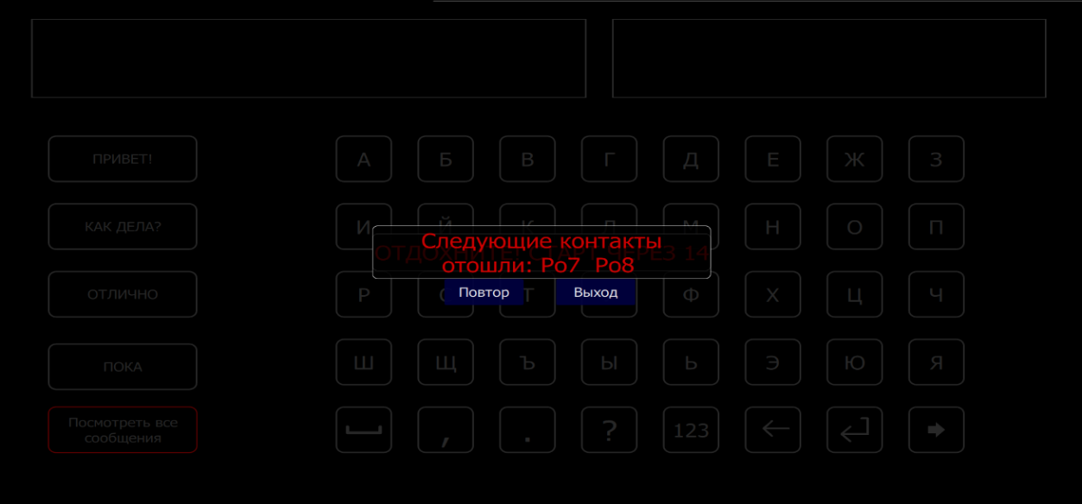
Illustration 56. Message «No connection with following electrodes: …».
To check the status of the electrodes go to the EEG info tab. This procedure is described in detail in section 4.1.
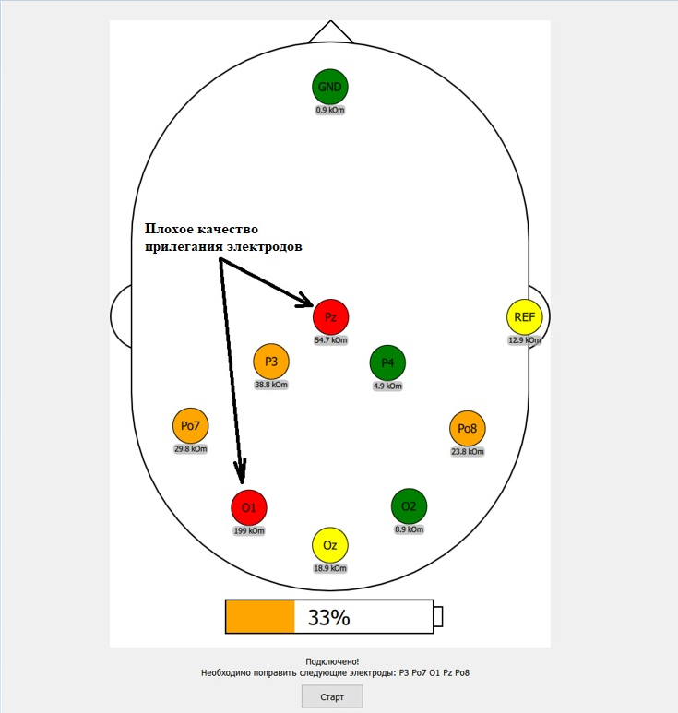
Illustration 57. Electrode status.
When you connect the headset, you might notice that the numbers under the colored circles change, which means that the electrode adhesion at some point in time may become better or worse, and the circle that was yellow may become green or orange.
After the message in Illustration 56, upon opening EEG info, the non-working electrode will be highlighted in the appropriate color (red or orange). To continue operating, add gel to the electrode, or correct its connection to the user's head, removing hair from under the electrode.
In case the electrode disconnection occurred at the calibration stage, you will have to start it again. If the calibration was completed and the electrode issue happened later, you need to fix the electrode and/or apply a gel under it.

6.5. Physically Damaged Electrode.
Before starting a session, it is necessary to inspect the electrodes. Inspecting the electrodes visually would be sufficient at this stage.

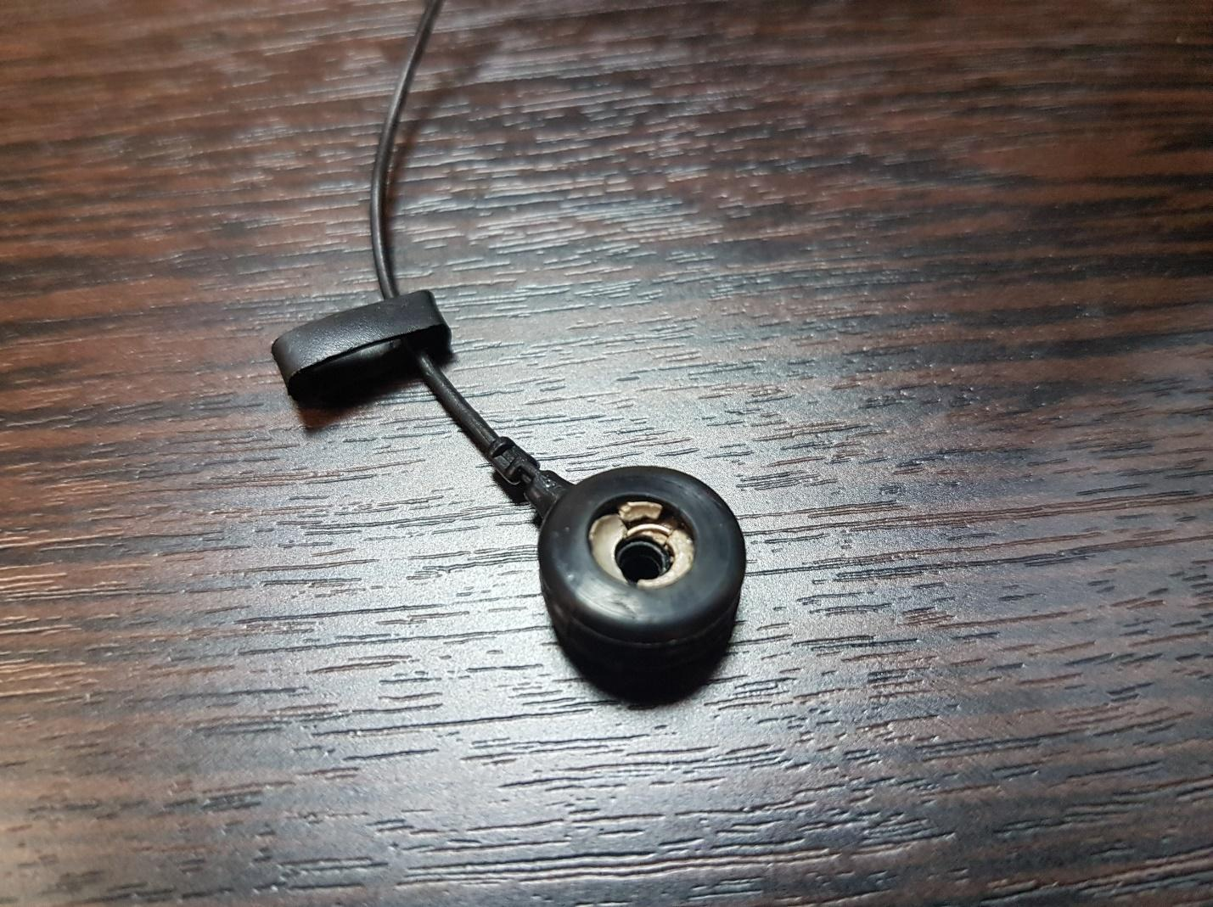
Illustration 58. Physically Damaged Electrode.
For example, the electrode shown in Illustration 58 has physical damage and will not work correctly. If any physical damage is detected on the electrode, you should immediately contact technical support for the subsequent replacement of damaged electrodes.

6.6. Forced Shutdown of Electrodes.
In instances where due to skull damage it is impossible to ensure electrode contact with the surface of the head or if the electrode is damaged, you can disable the operation of this electrode.
You do not have to shut down the electrodes if the hair of the user is very thick and voluminous, and the electrodes seem to be not working. Electrodes should be able to touch the scalp of the user, and this can be done in multiple ways: by carefully separating the hair around and under the electrodes, by unstrapping the side mount straps («spider») and placing them under the frame of the headset, by tightening and adjusting the overhead straps, by using cotton pads under the rim, as well adding larger amounts of conductive gel.
Для отключения электродов откройте меню программы (подробное описание приведено в section 4.1), перейдите во вкладку EEG и уберите галочку напротив названия отключаемого электрода (Illustration 59)
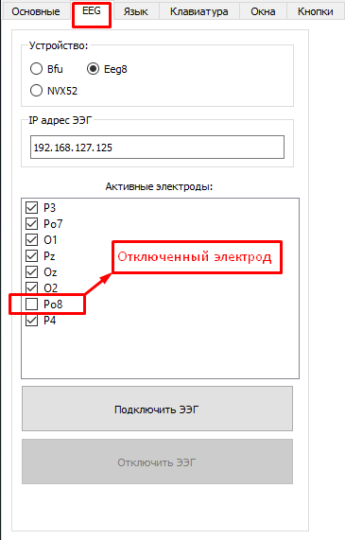
Illustration 59. Forced Shutdown of the electrodes.

After disconnecting the electrode on the «EEG Info» tab, the electrode will turn grey (Illustration 60):
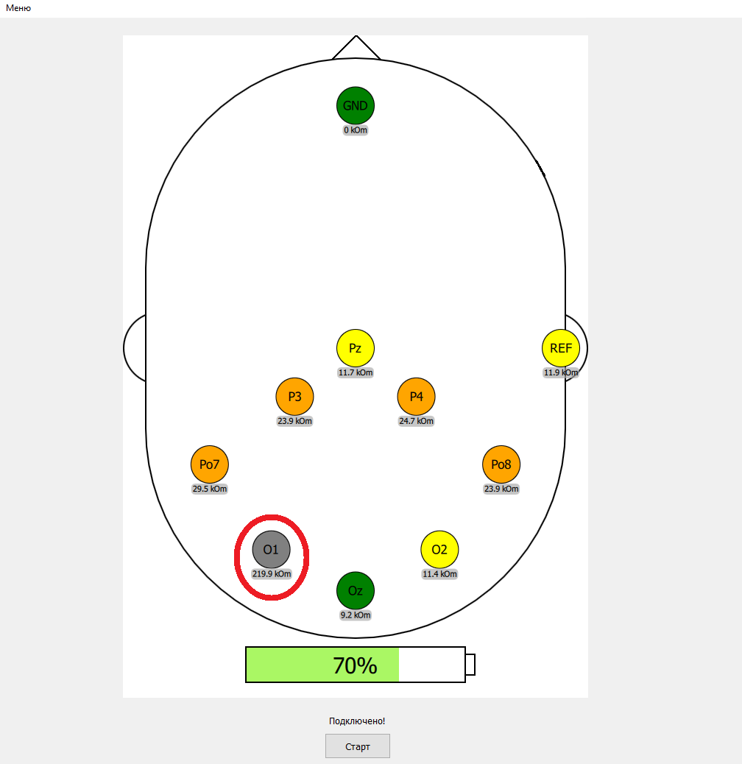
Illustration 60. Disconnected Electrode.
After disconnecting the electrodes please do the calibration again.
IMPORTANT: Disconnection of one or more electrodes (3 maximum) will cause decrease in typing speed, as well as create a higher chance of making a mistake when typing.
Shutdown of the electrode is only allowed in exceptional cases when correct installation of the electrode is impossible.

The following electrodes are not recommended to be disconnected at the same time:
- In central-parietal region (P3, Pz, P4)
- Electrodes in left or right occipital region (PO7, O1, Oz or PO7, O1 – left; PO8, O2, Oz или PO8, O2 – right)
- Both electrodes in lateral occipital region (PO7, PO8)
- When disconnecting either PO7 or PO8 electrodes it is not recommended to shutdown Pz electrode
Additional recommendations on disconnection of the electrodes:
- There should be at least one operating electrode in central-parietal region (P3, Pz or P4)
- It is highly advised to use Pz electrode

7. «Memory»
«Memory» – is a game that improves memory and trains concentration of user’s attention. At the start of the game user will see a screen with all cards open. After a few seconds, the cards will «disappear». The goal of the game is to open the cards one by one and try to match the ones that look the same. First card selected will stay open on the screen until the second card is opened. If the correct pair is found those card will no longer be of choice; if the selected cards are different, both card will be closed again.
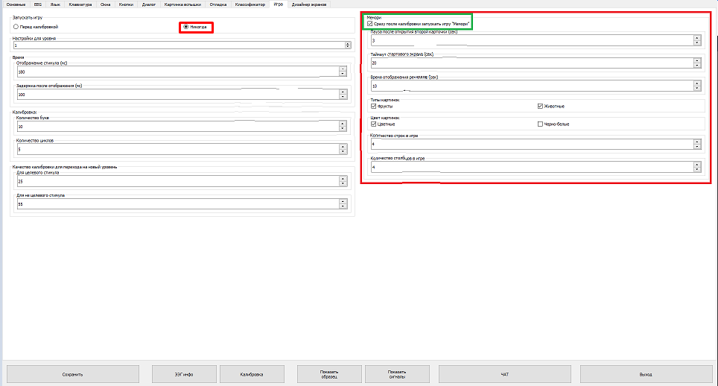
Illustration 61. «Memory» Starting Screen.

It is recommended to start playing the game when the calibration score is at least 80/30. If the user is unable to achieve this score from the first try, repeat the calibration process.
To launch the game tick the box in the corresponding window (green frame: Illustration 61). Make sure that in the top left corner of the screen in «Start Game» field the «Never» position is chosen.
Adjust game settings:
- «Pause after opening the first card» - time after which chosen cards will either close again or disappear from the screen
- «Start Screen Timeout» - initial time given to memorise the cards
- «High Score Time» - displayed time with results.
- Choose the type and colour of the pictures, set the amount of cells.
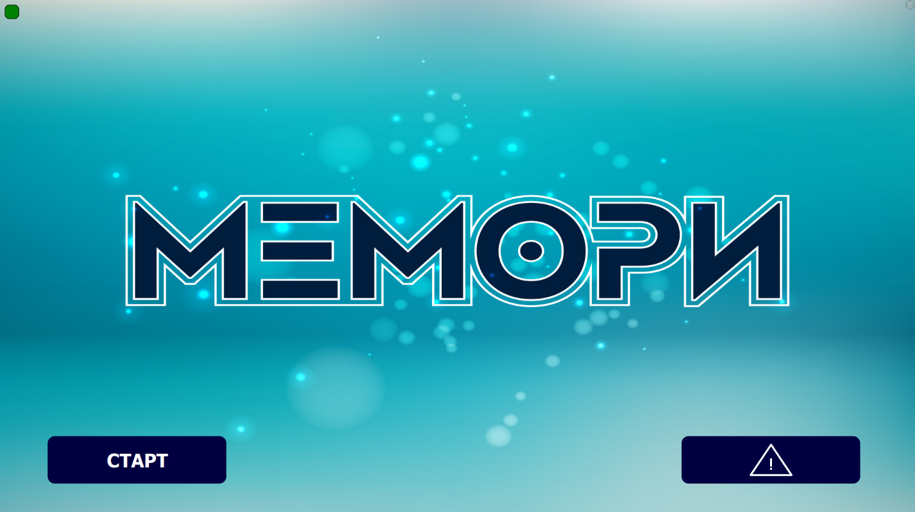
Illustration 62. Starting Screen of «Memory».
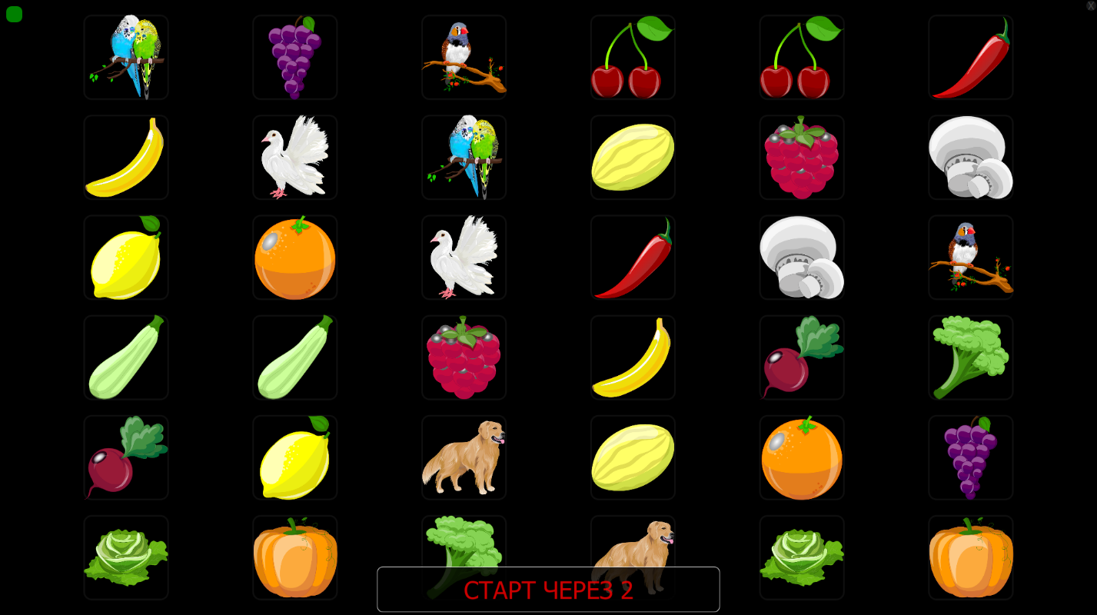
Illustration 63. «Memory»: first screen.
After launching the game user will be allocated some time to remember the location of pictures. The length of time given for memorization, as well the amount of rows and columns can be changed in settings.
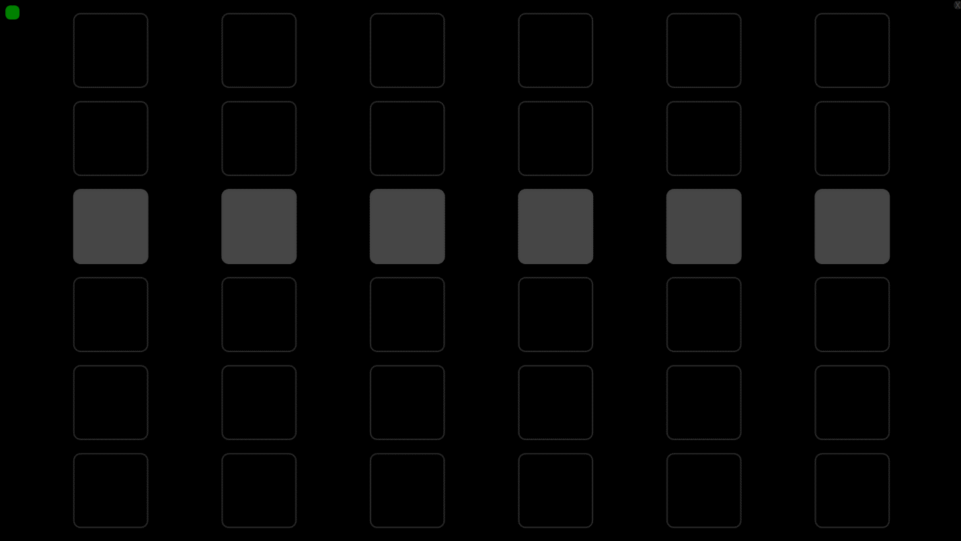
Illustration 64. Closed cards
Cards will be closed when the time given for memorization is up. To open the first card let the user focus on a cell.
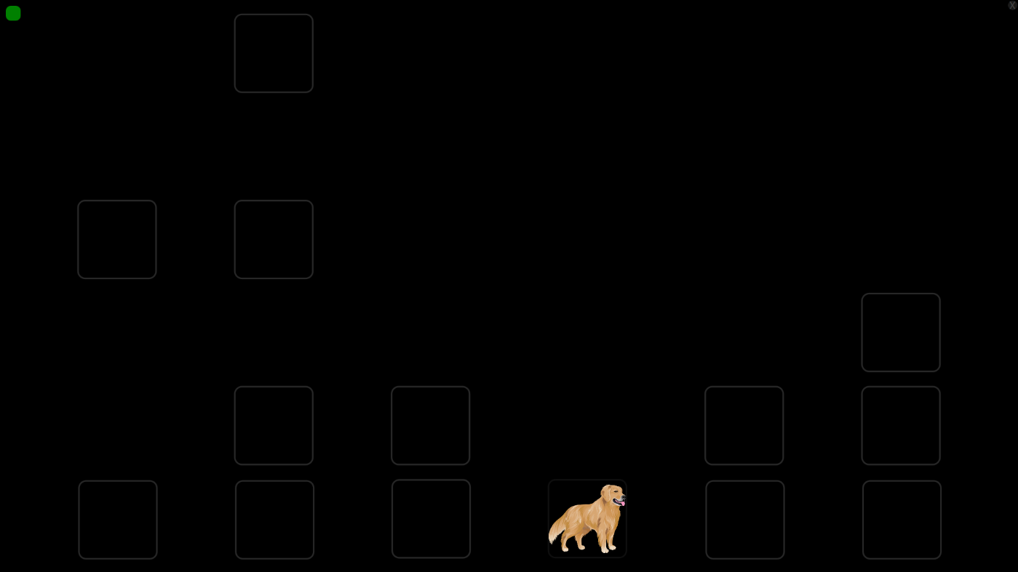
Illustration 65. Opened card
When the card is open it remains on the screen until the second part of the pair is selected.
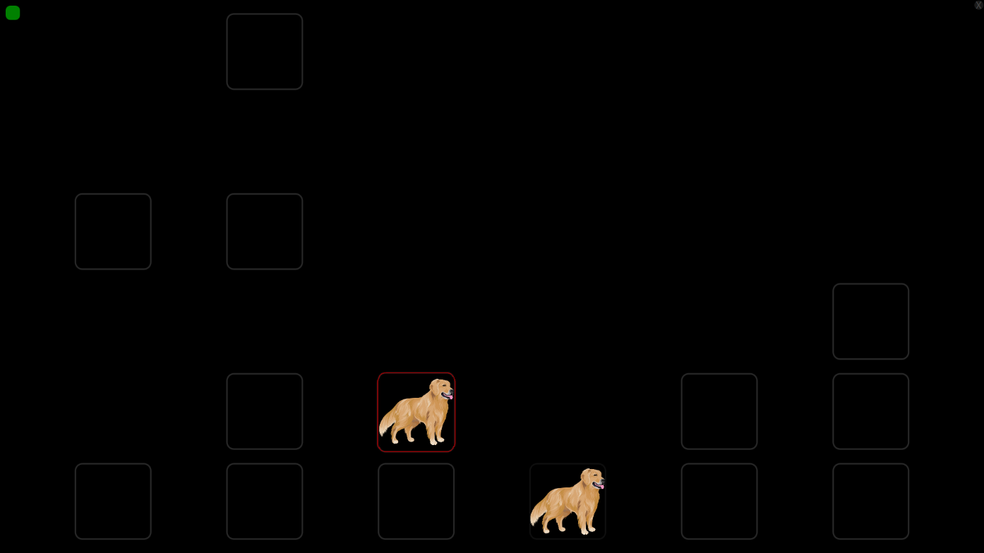
Illustration 66. Opened pairs
When the second card is opened, the pair remains on the screen for a few second and then disappears. If the correct pair is selected, those cards wll no longer be shown on the screen.
The game is completed when all pairs are chosen correctly.
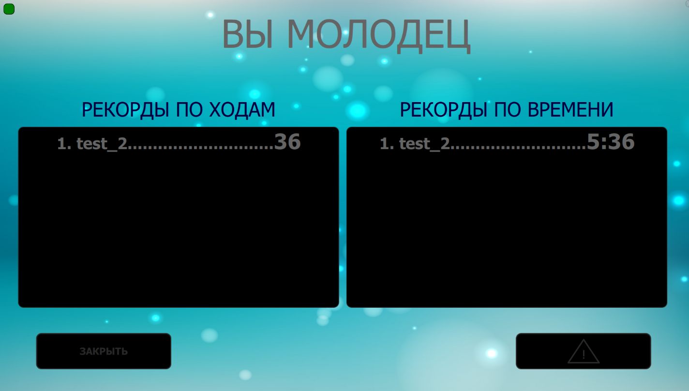
Illustration 67. The End of the Game

8. Training Mode
To turn on the training mode go to the «settings» menu, select «Game» and tick the box (Illustration 68). Now, when selecting Теперь после нажатия кнопки «Start» in «EEG Info» the game will launch before the calibration. You may also launch the game manually by opening the NeurochatGame.exe file which is located in NeuroChat folder.
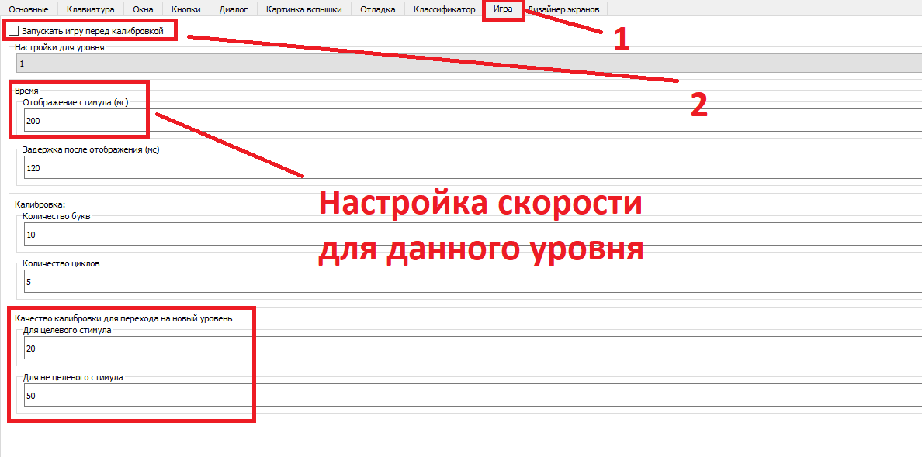
Illustration 68. Turning on the Training Mode
Each level has its own settings, as well as the minimum score needed to proceed to the next level. To do so, select the level in «level settings» field, and set the desired speed in «Stimulus Display» field or change the calibration quality requirements (Illustration 68).

After starting the program, you will see a window with instructions (Illustration 69). Note that each level has its own instruction.
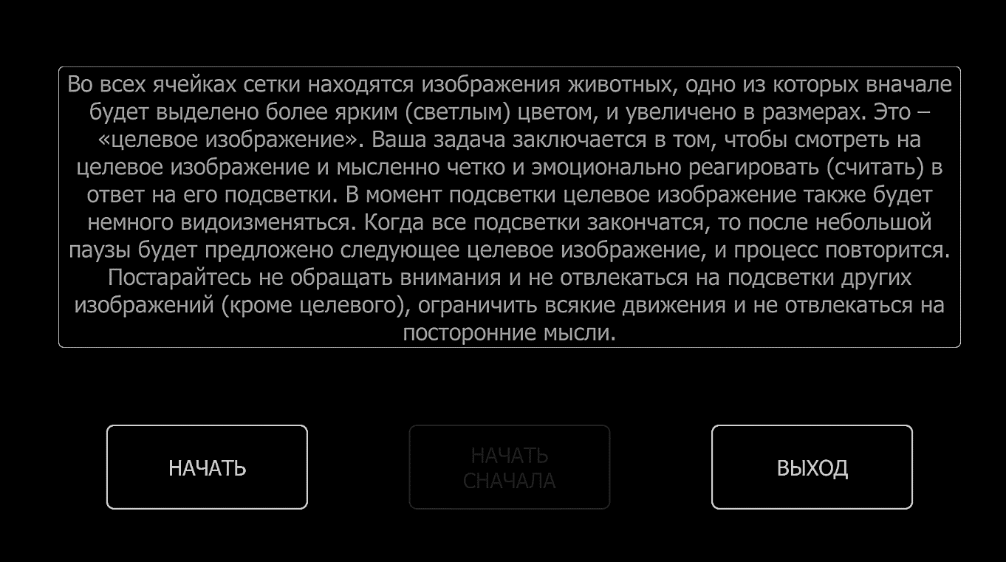
Illustration 69. Training Program Instructions.
After reading the instructions for each level, click «begin» in the bottom left corner of the screen.
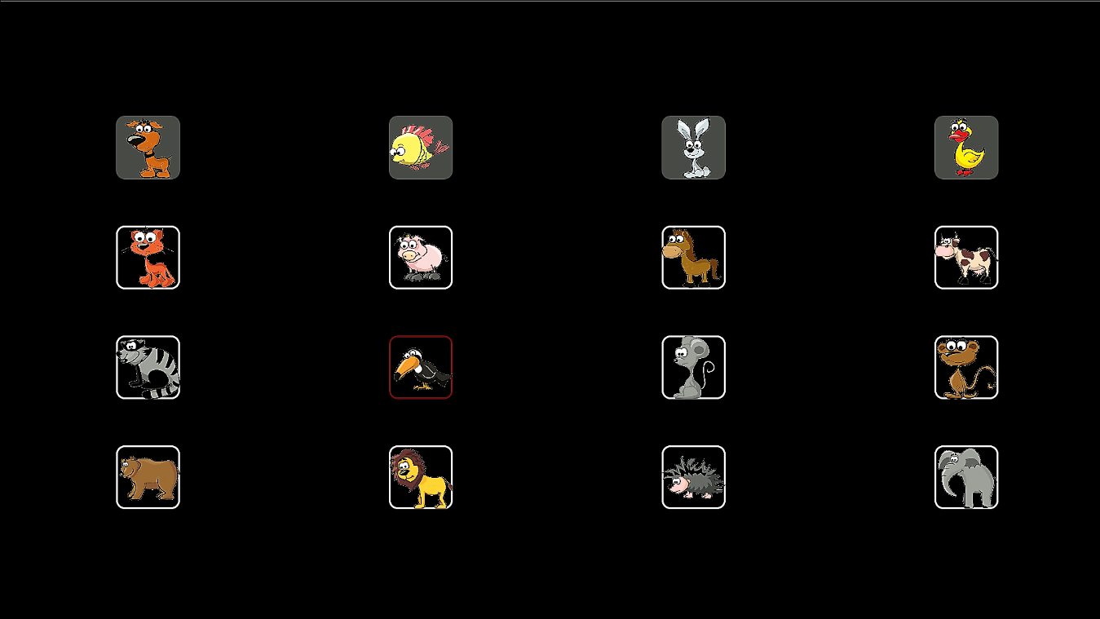
Illustration 70. Training Program – Level 1
Illustration 70 shows the first level of the training program NeuroChat. Calibration results are shown during completion of each level. As you go further in the game the speed of flashes increases.
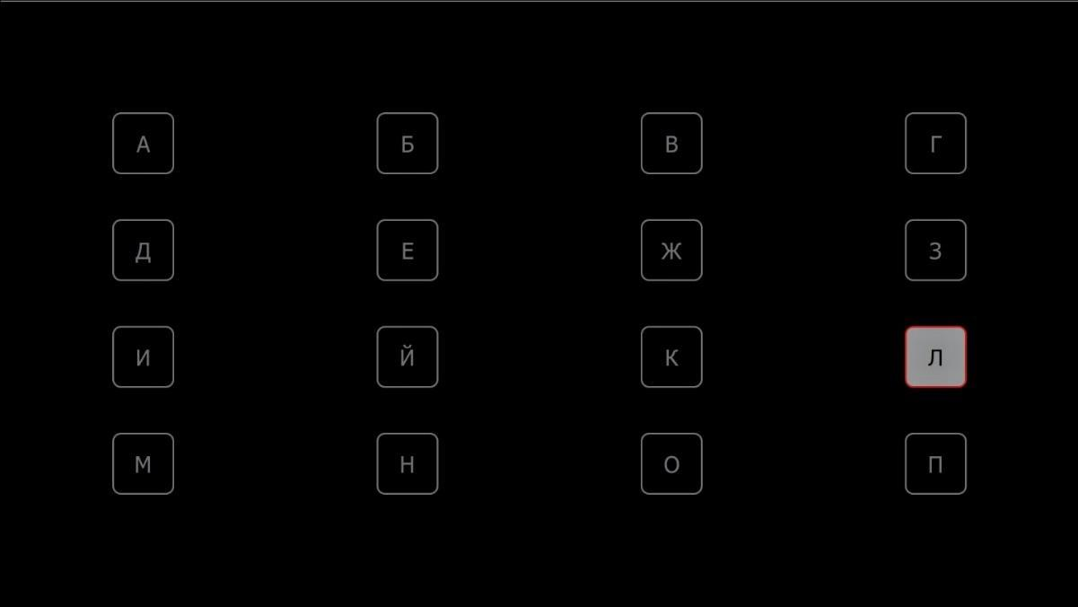
Illustration 71. Training Program - Level 3
Level Description:
Level 1 – 4х4 matrix with pictures (when highlighted, the target enlarges and becomes animated);
Level 2 – 4х4 matrix with pictures;
Level 3 – 4х4 matrix with letters (Illustration 71);
Level 4 – 5х5 matrix with letters;
Level 5 – оriginal matrix, used during calibration.

NOTE
The training mode can be used for children who do not know the alphabet, as well those people who work with NeuroChat for the first time. This mode was created to train and improve concentration of attention. Training mode will also be helpful to those who are already familiar with NeuroChat but want to increase the typing speed and improve the calibration results for future trainings.
9. Screen Designer
9.1. Editing the screen
To work with the Screen Designer it is required to have basic skills operating with computers on an advanced level.
To create and edit personal screens go to the «Screen Designer» tab (menu – settings – screen designer) and select «change». (Illustration 72).
IMPORTANT: When you launch this mode for the first time, edit this screen first and then create a new one.
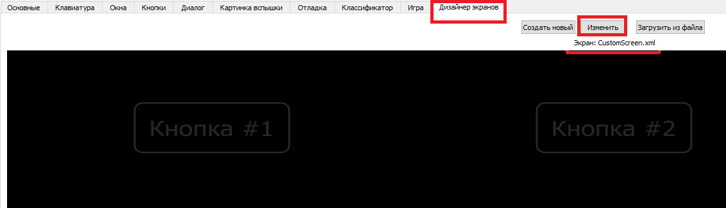
Illustration 72. Screen Designer
After selecting «change» the user will be moved to the «Screen Settings» (Illustration 73).

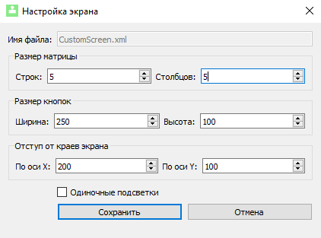
Illustration 73. Screen Settings
Set the desired amount of columns and rows, change the size of the buttons (if the buttons start to overlay, they will automatically be changed to a smaller size) and the indent of the screen edges. X axis - indent on the right and left, Y axis - top and bottom. When creating screens of 3 x 3 or less (9 cells or less), tick the «Single Backlights» box (Illustration 74 and Illustration 75).When you are done with changes, click «save».
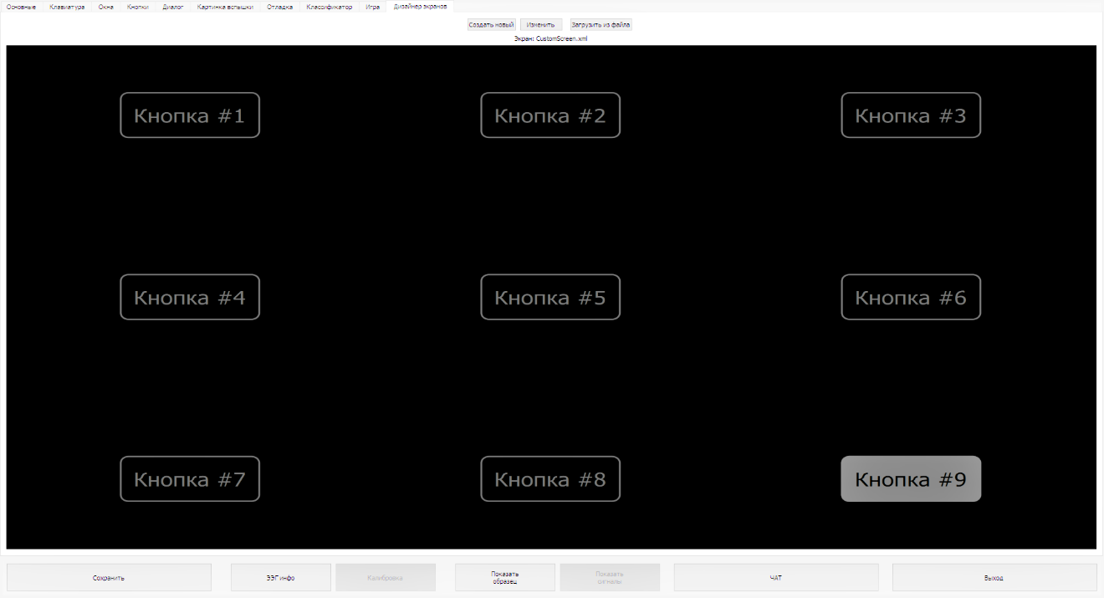
Illustration 74. 3 rows and 3 columns selected, single backlights are on.

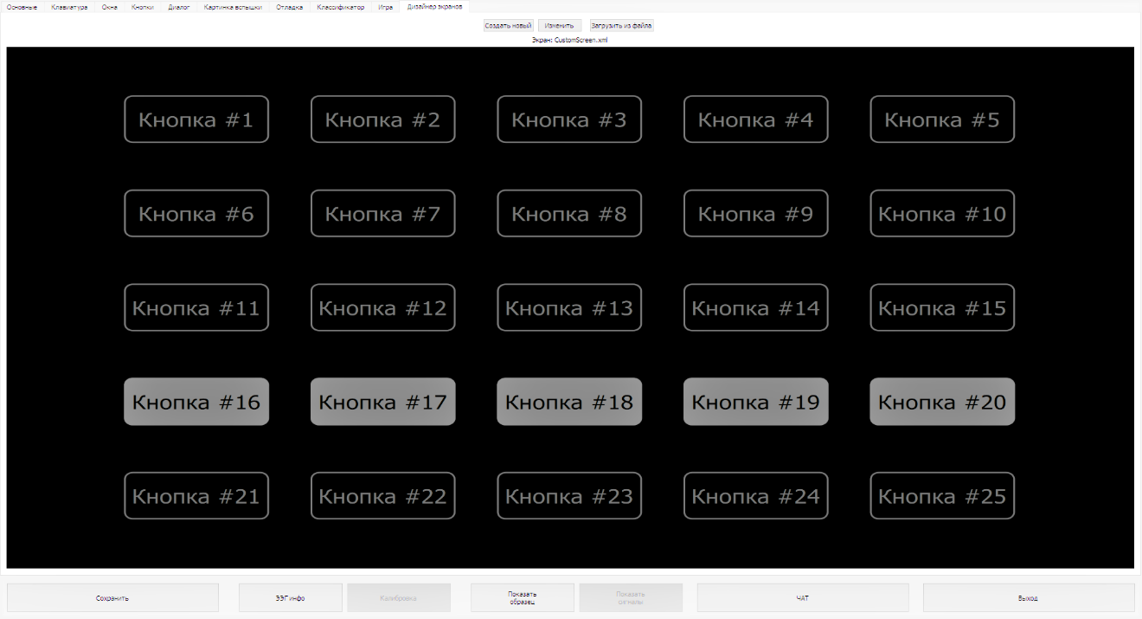
Illustration 75. 5 rows and 5 columns selected, single backlights are off.

9.2. Button Settings
To customize the button, move the cursor to the desired button and use left click. The «Edit Button» window will open (Illustration 76).
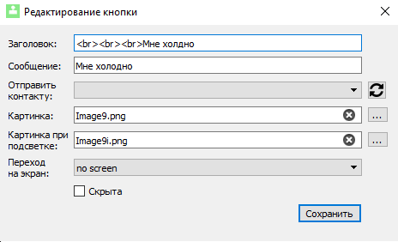
Illustration 76. Editing a Button.

Title – text inside the button (e.g, «Button#1»);
Message – text that will appear on the screen when selecting that button, if «no screen» is chosen in the «go to screen» field;
Send to the contact – user is able to select a recipient who will receive his message (the message will be duplicated on the screen);
Image – image inside the button;
Image with a backlight - image with backlighting is a picture inside the button when the stimulus is highlighted. If an image is inserted without backlighting, then during flashes the background of the button will change.
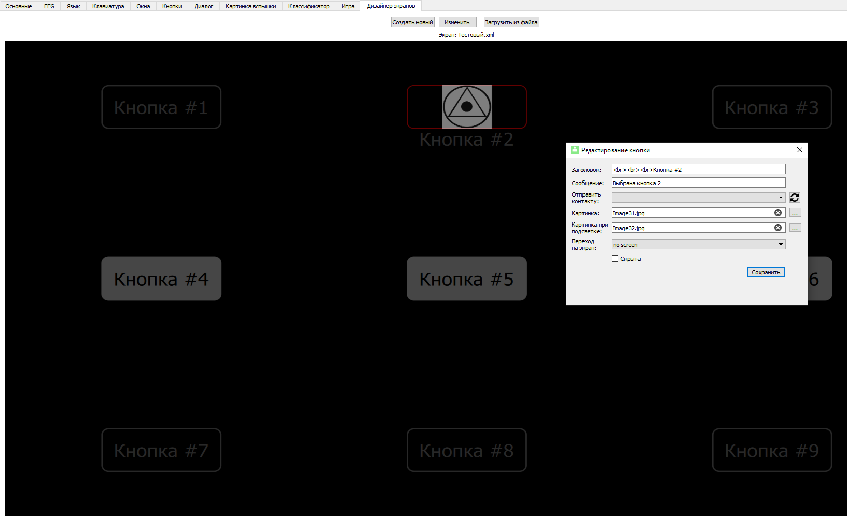
Illustration 77. Part of the screen and «Edit Button» window.

To take the text beyond the borders of the button (down) enter html-tag <br> before the text (depending on the size of the buttons, the tag may be repeated (to achieve the desired indent on Illustration 76 the tag was used 3 times)). You can also leave the field blank (delete text) and leave only the image or hide the button. To hide a button, tick the corresponding box in the «Edit Button» window (Illustration 76). When you hide the button it will become dark gray in the screen editor (Button 3 on Illustration 77) and it will be completely hidden when working on the screen. After making the desired changes to the buttons, click «save».
Note: html-tags, such as <i>, <b>, <font color="#123456"> work as well.
IMPORTANT: Each screen should have one of the buttons must be set to either go to the previous level or to the main menu.
9.2.1. Changing Images Inside the Buttons.
To change an image inside the button select the auxiliary window (Illustration 78):
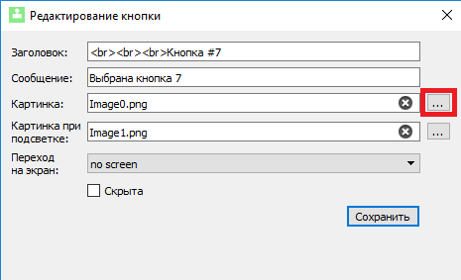
Illustration 78. Окно «Edit Button» window with a chosen button for inserting an image.
A window that allows you to select an image for desired button will appear (Illustration 79). The images in following formats are supported: jpg, jpeg, bmp or png. Choose an image and click «open» in the bottom right corner of the screen.
Illustration 79. Image Selection Window.
When choosing any image, its copy is saved in the following place: ...\Neurochat\CustomScreens\Images. When the picture is selected, its name is displayed in the «image» field (Illustration 78). There is also a cross (X) at the end of the field in case you wish to remove the image from the button(a copy is saved after the picture is deleted).
When a button with a picture inside is highlighted, unless another image is inserted, the background of the button will be displayed. Inserting an image with a backlight is similar to inserting a picture inside a button in the corresponding «Backlight Picture» field. For example, on (Illustration 80) you can see the previous image with inverted colours.
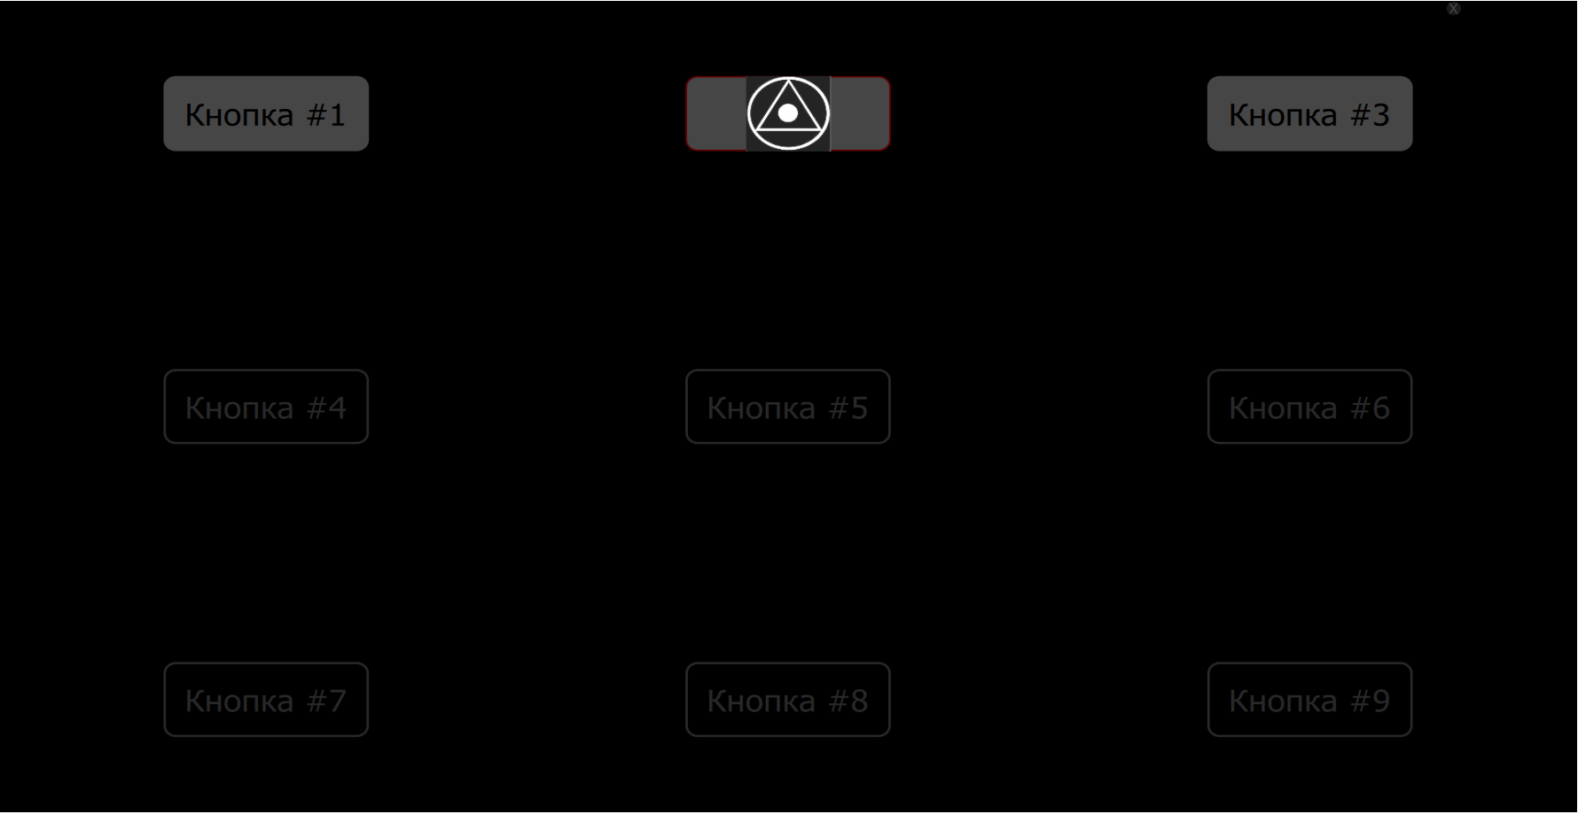
Illustration 80. Image «Button 2» with a backlight.

After the changes are saved the screen will show the set image which was scaled according to the size of the button (Illustration 81).
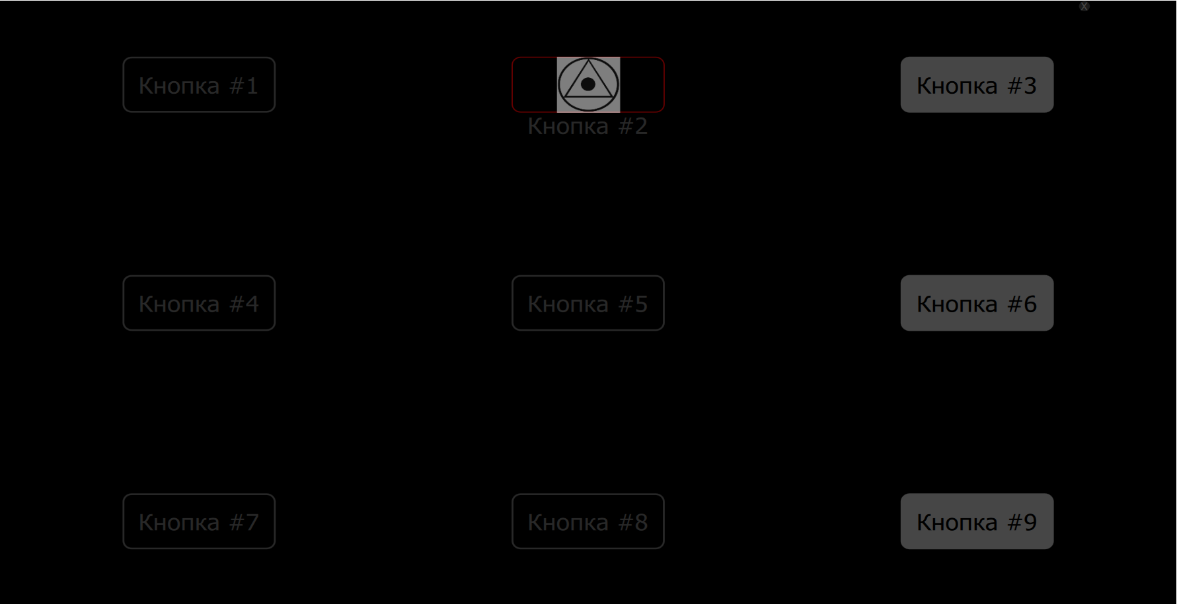
Illustration 81. Установленное на «кнопку 2» изображение отображено на экране.

9.2.2. Setting Buttons to Switch to Other Windows.
To assign a button to go to another window, click the drop-down list on the right of the corresponding field (Illustration 82). If «no screen» is selected, the text from «message» will be displayed. If «main» is selected, you will be redirected to the main screen (section 5.2 Illustration 40) and the message will not be displayed. Next are the names of the personally created screens. CustomScreen - the first screen that was edited (it will open from the main menu). To go to a different window, select the name of the corresponding screen.

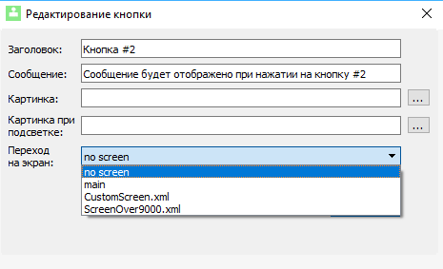
Illustration 82. Screen Selection.

9.2.3. Image Format Requirements.
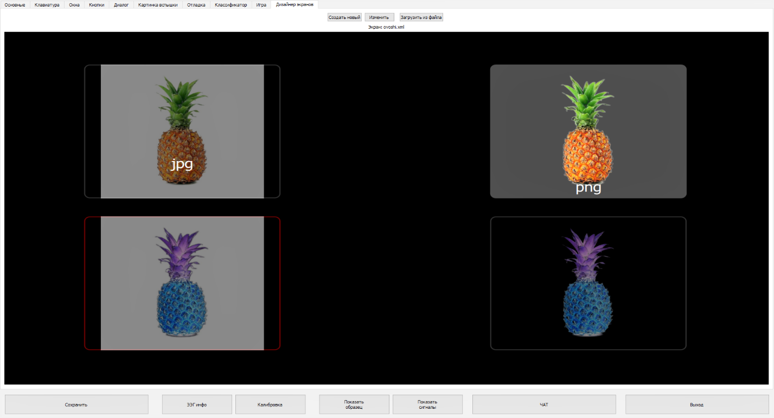
Illustration 83. Difference Between jpg and png Image Formats.
Formats such as jpg, jpeg and bmp do not support partial transparency (alpha-channel), unlike png files. The difference is clearly visible on Illustration 83 - images in jpg and jpeg formats contain a background. Such image, inserted inside a button, will stand out colorwise from the frame of the button. You can insert such images, but you will not be able to edit the background.
NeuroChat does not support the downloading of vector images (svg, swf, etc.), animations (gif) and uncompressed bitmap files (tiff, etc.). To convert from svg, jpg, bmp and other formats to png, as well as to remove the background from bitmaps, you may need a third-party software. (example. Gimp). Programs like Paint and Paint 3D are not suitable for converting images to png format, as they do not have special functionality for selecting specific areas for background removal.

9.3. Screen Creation and Loading
To create a new screen click the corresponding button in the Screen Designer tab (Illustration 84):
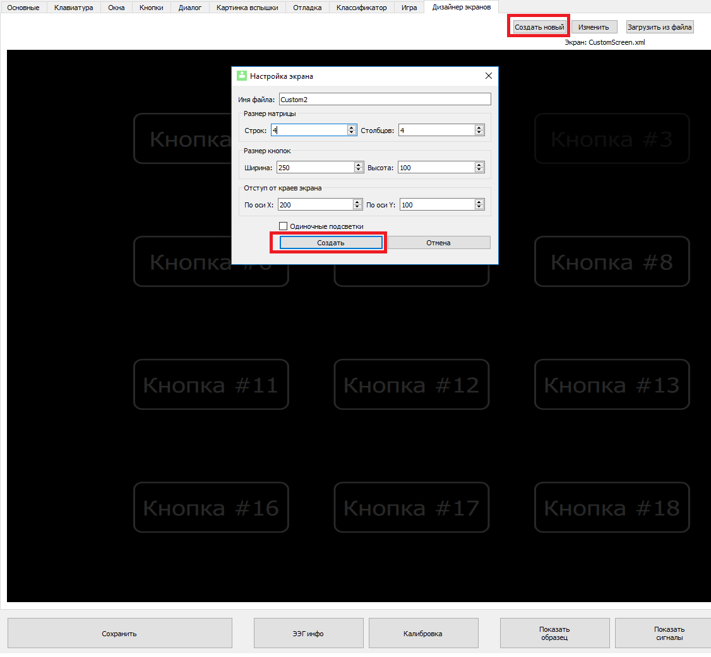
Illustration 84. Creating a New Screen.
Choose the desired number of rows and columns, set the size of the buttons, as well as the indent and click «create». The name of the opened screen will change under the «change» button.
To switch between previously created pages, click the «load from file» button and select the desired window. Editing of all the screens is possible with the help of Screen Designer in the NeuroChat program. You can delete the windows from the \Neurochat\CustomScreens folder.

